Setting up Local Environment

# Software required

* + Web logic 12
  + SQL Developer
  + My Eclipse 2015 CI
  + Tortoise SVN

# Source to pick the installations

\\BLR-MOB0028\Users\ASrinivasan\Downloads\FEMS_EXE

Asokan_Shared_Folder

Examin_Technical_Specification_Integrated.do

FileZilla_3.10.1.1_win32-setup [1].exe

Jdk-8u31-windows-x64.exe

jdk1.6.0_45

lib.zip

lib_upgrade

Middleware

Myeclipse-2015-2014-12-04-offline-installer-

properties

putty.zip

python-3.4.2.amd64.msi

SkypeSetup.exe

SmartClient_SNAPSHOT_v101d_2015-01-07_PowerE

spark_2_6_3.exe

sqldeveloper-4.0.3.16.84-x64.zip

tasklist

TortoiseSVN-1.6.12.20536-x64-svn-1.6.15.msi

wls1036_dev.zip

# Steps of installing

* + Copying the Middleware directory
  + myeclipse-2015-2014-12-04-offline-installer-

# Configurations

Create a new Web Project File -> New -> Web Project

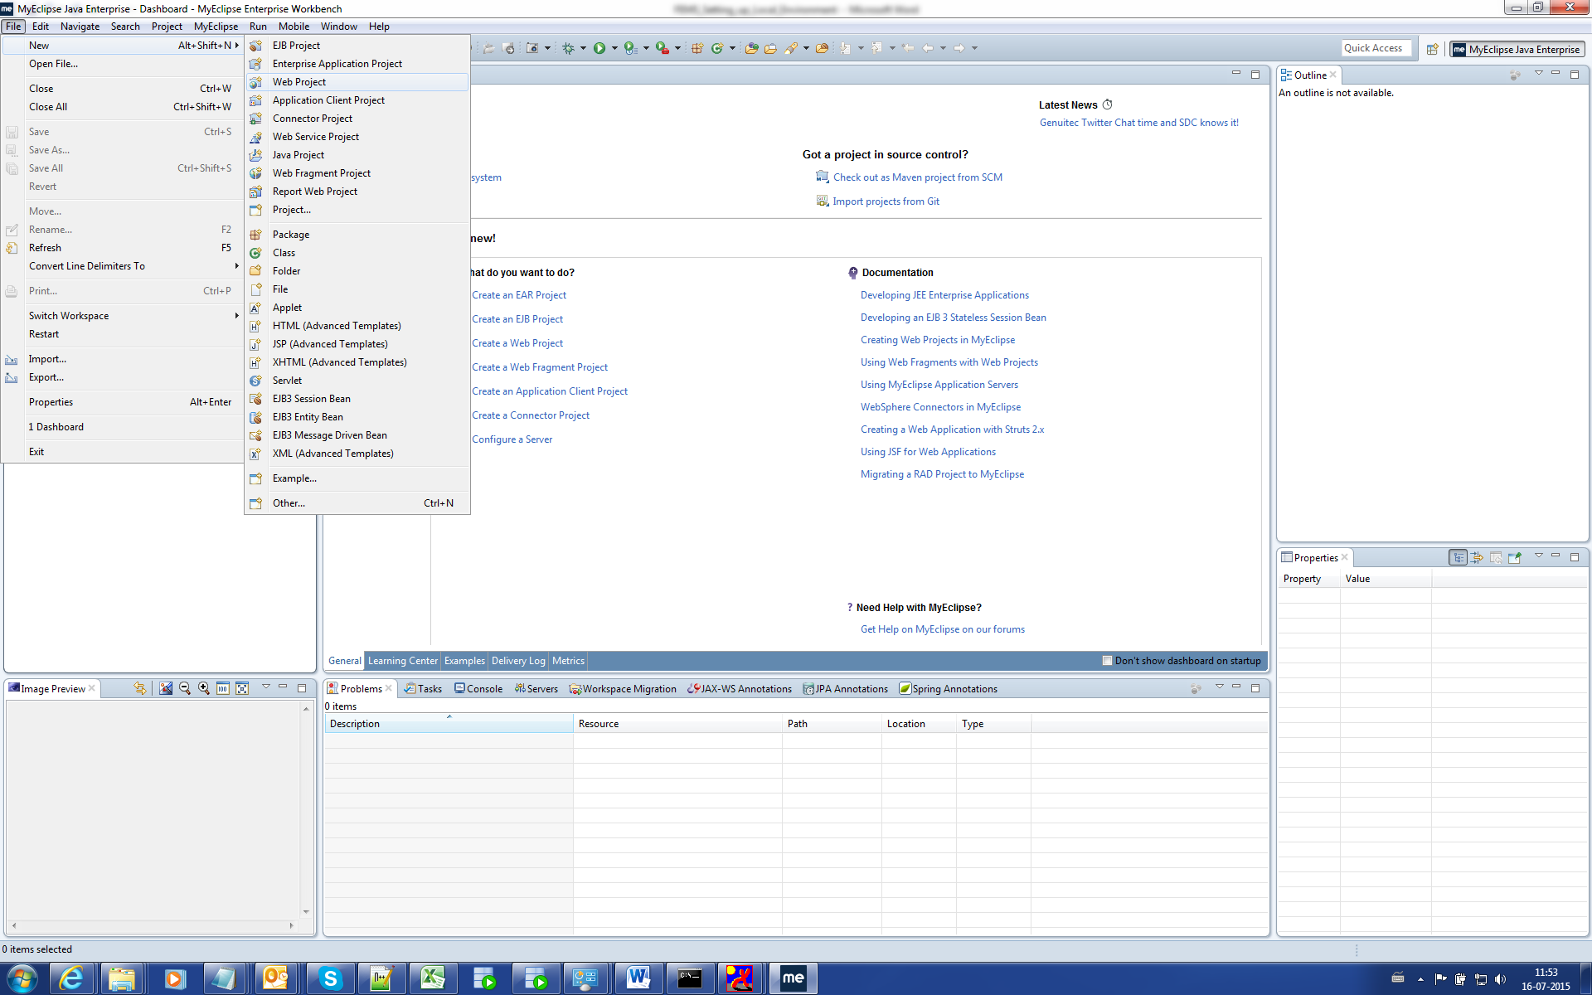

Project Name: examinWeb

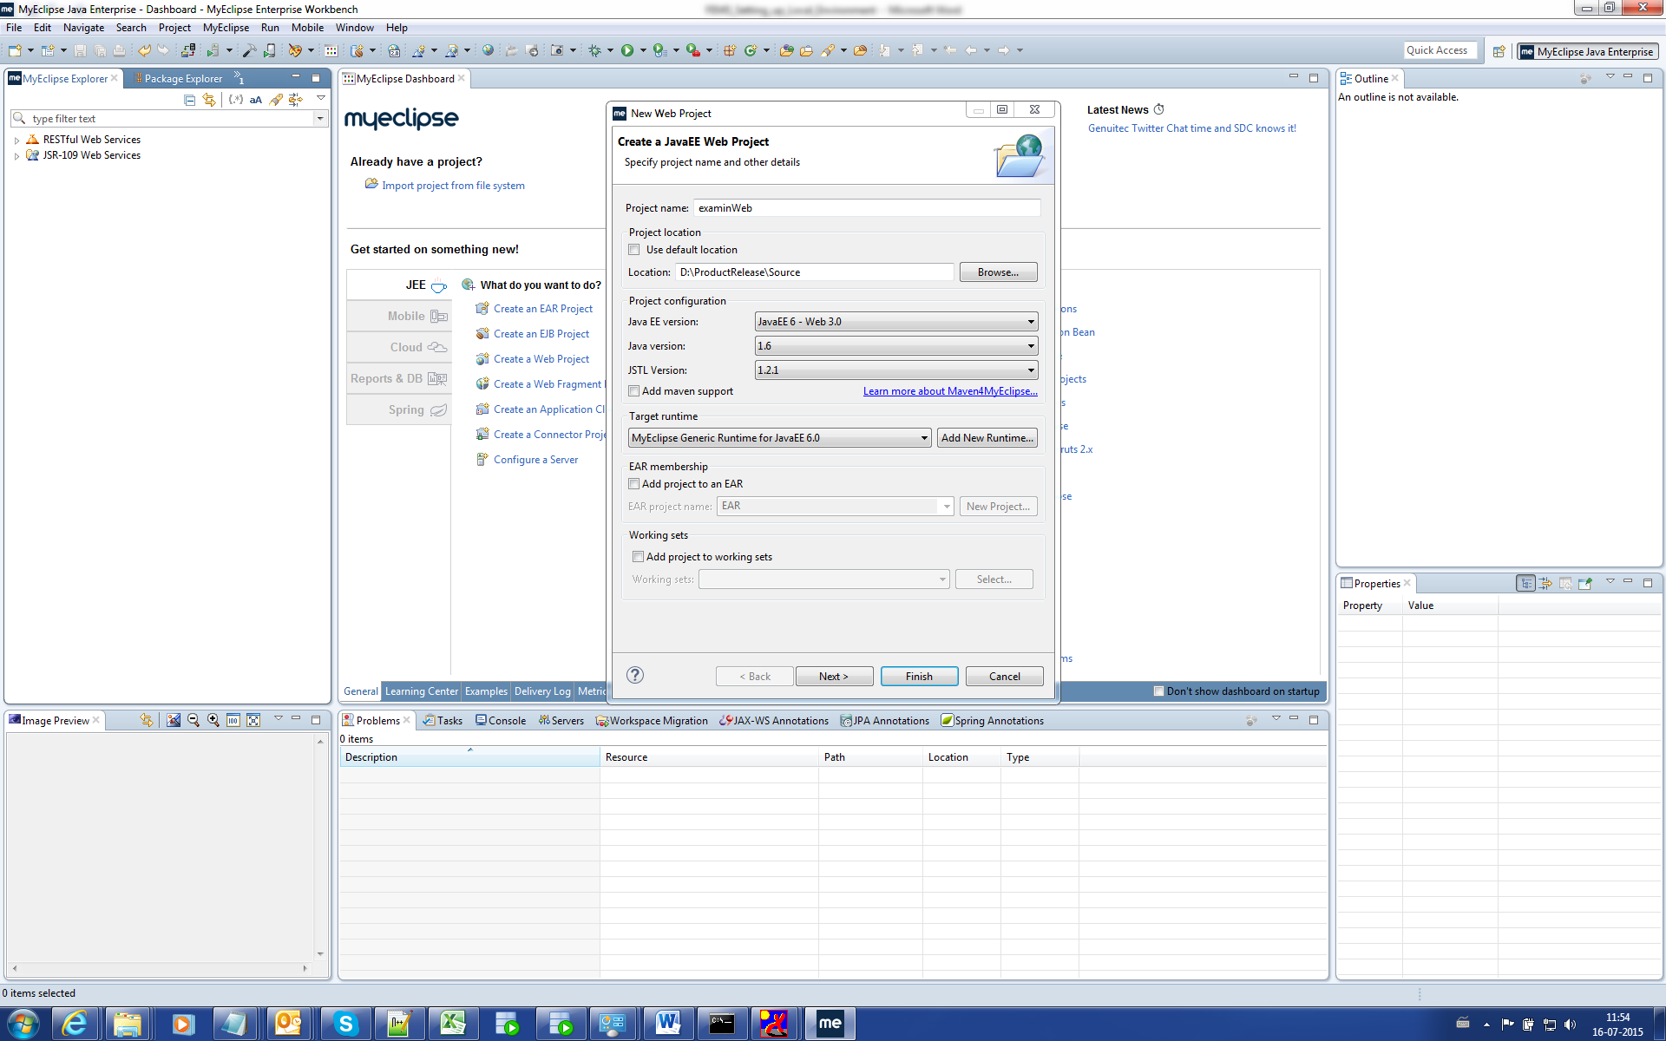

Click Add New Runtime and choose Oracle WebLogic Server 12c as below.

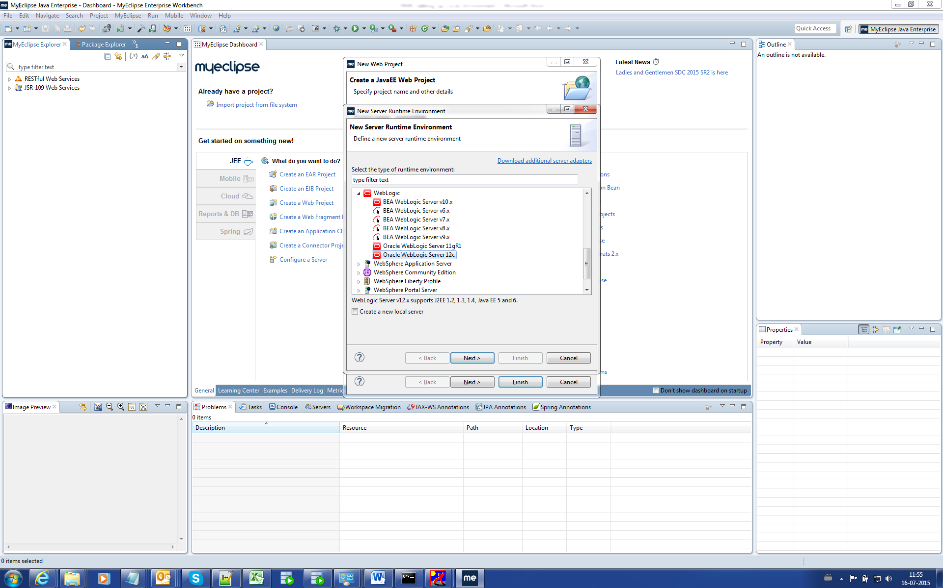

Click Next.

Browse 🡪 set Middleware 🡪 Oracle_Home folder as Installation directory then Finish.

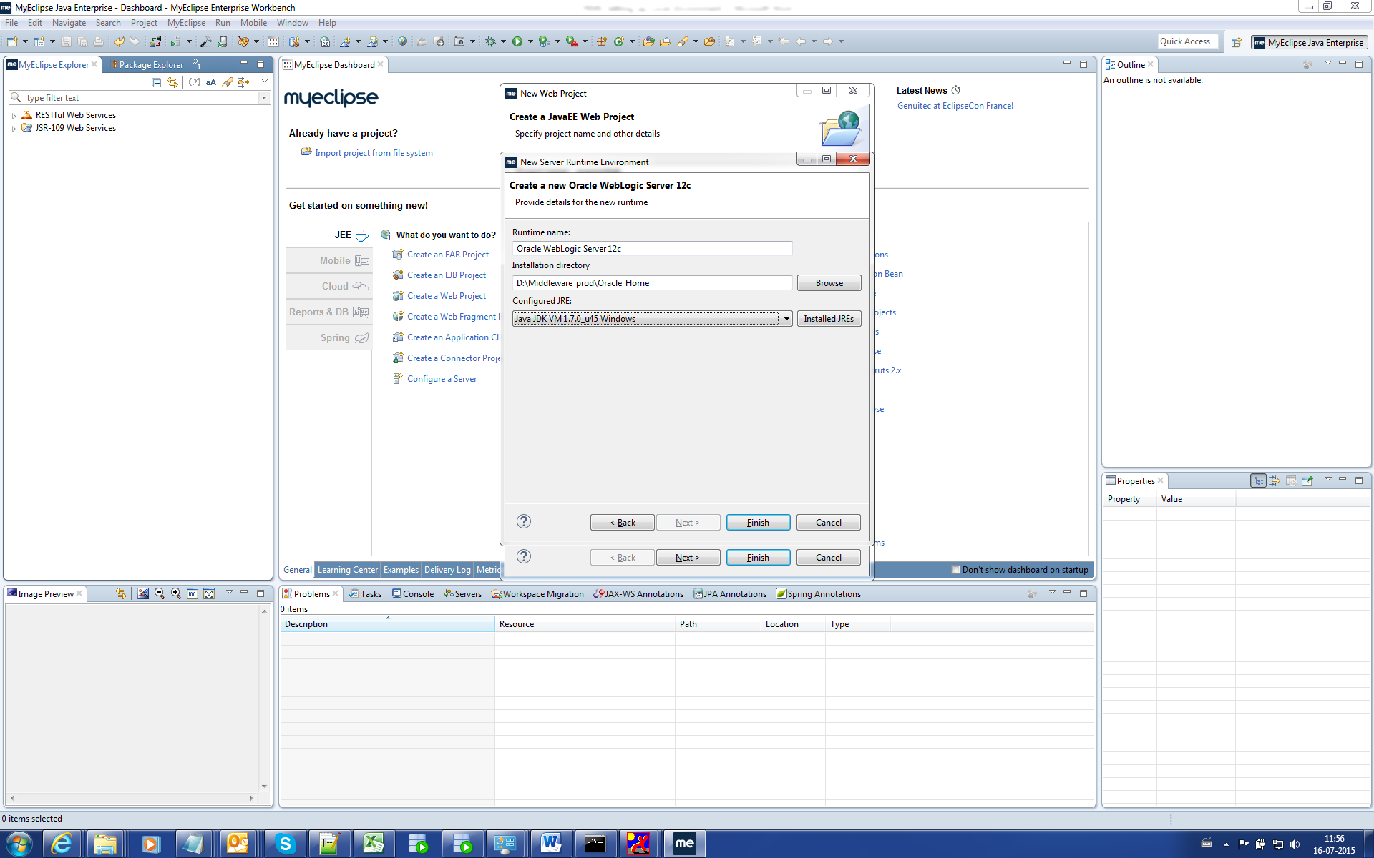 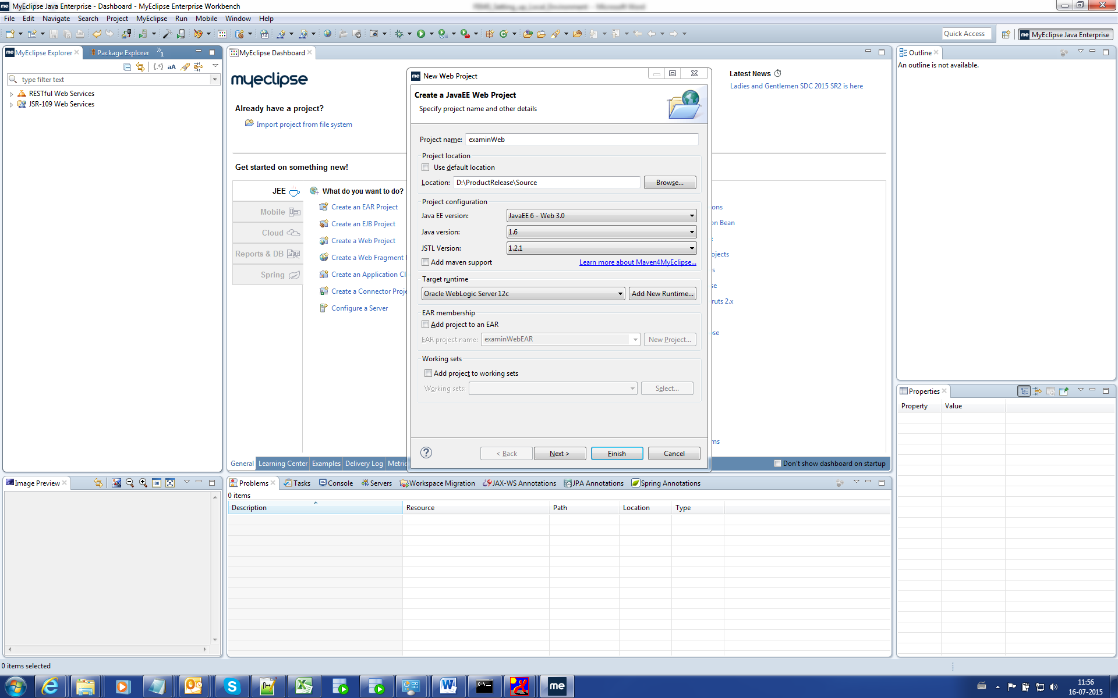

Click Finish.

Remove the Soruce folder “src”. 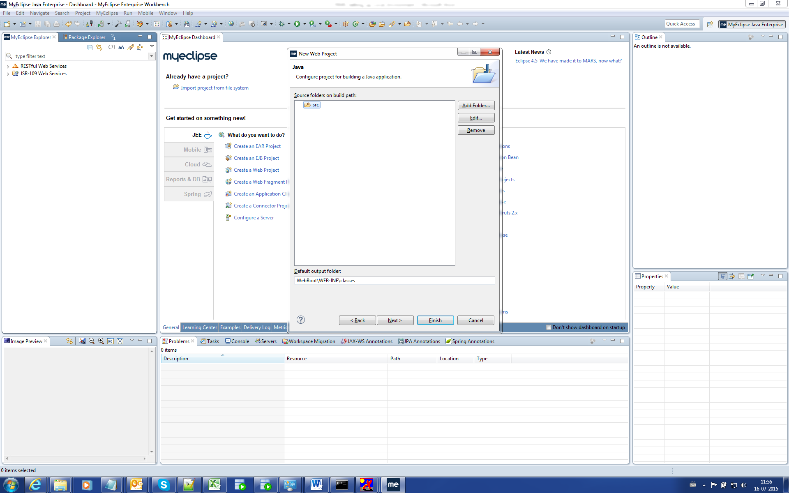

Add a folder called “java” and change Default output folder from “WebRoot\WEB-INF\classes”to “WebApp\WEB-INF\classes” as below.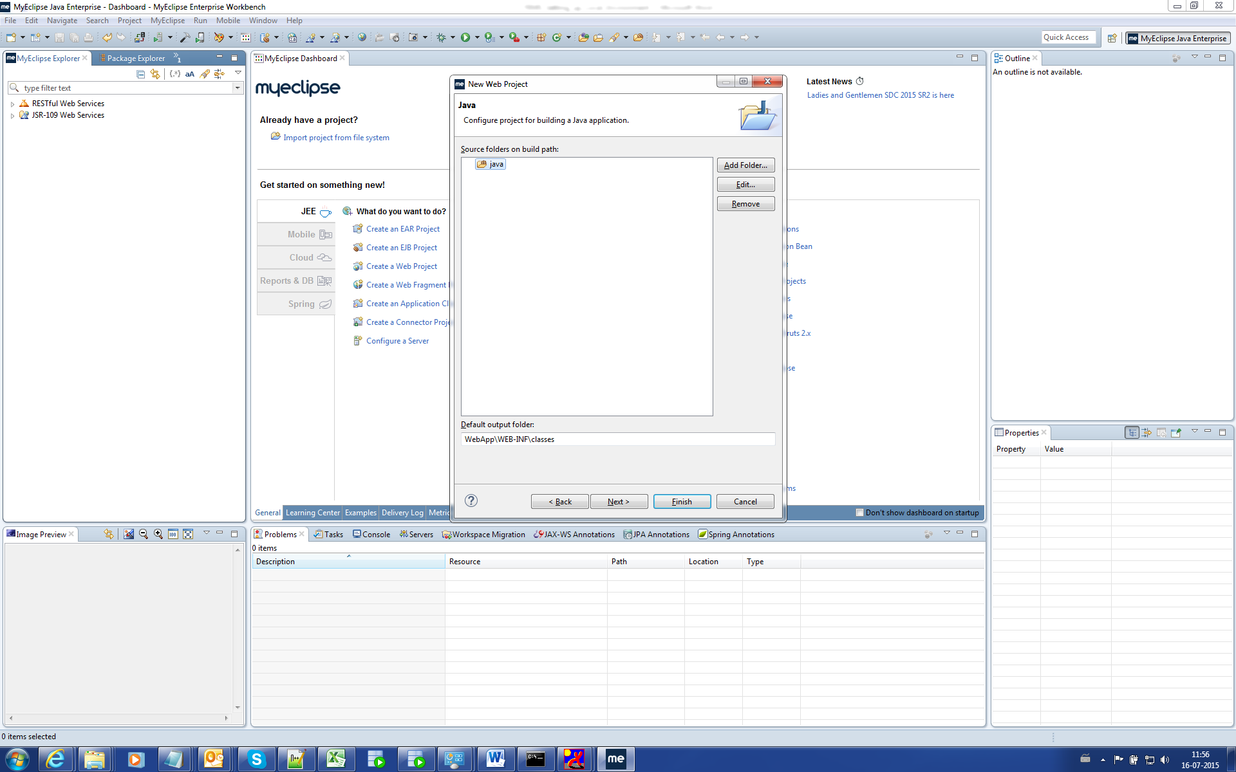

Click Next

Change the Content directory as “WebApp”.

Uncheck the “Generate index.jspwelcome file”.

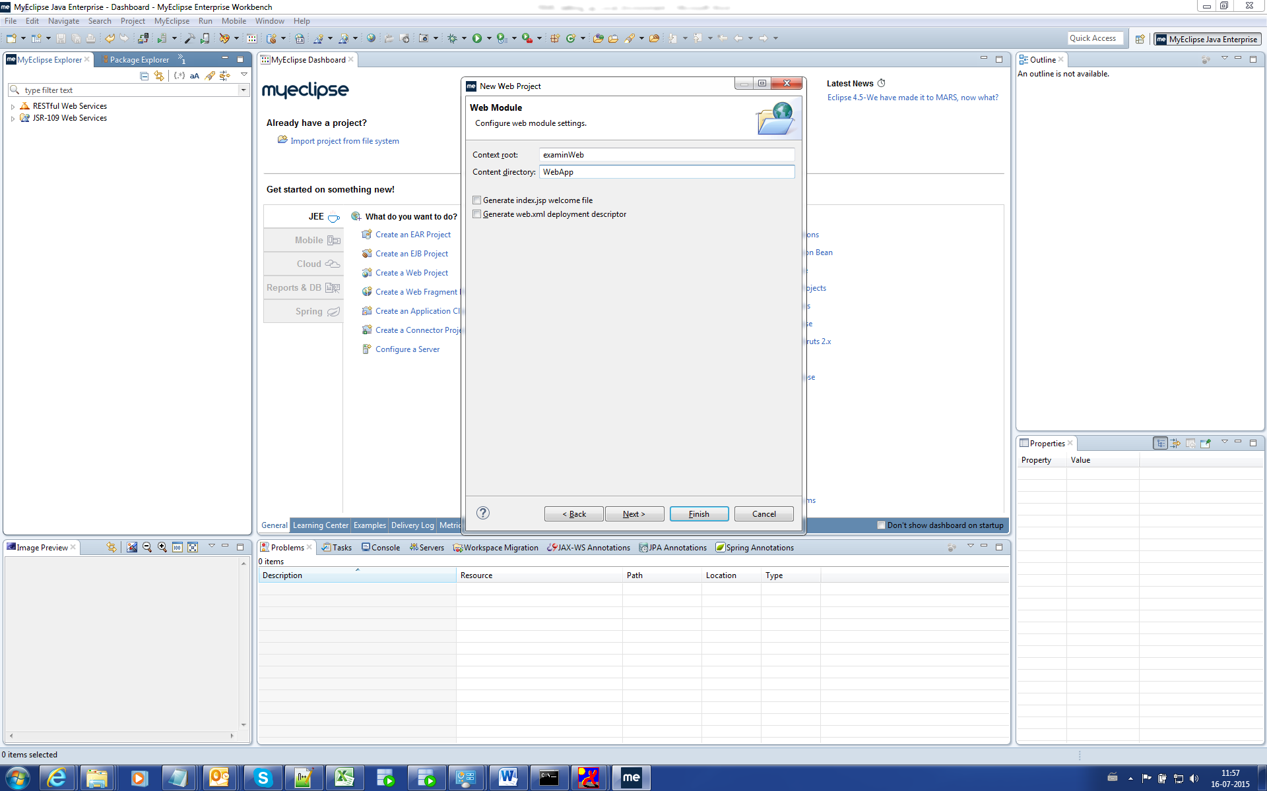

Click Next.

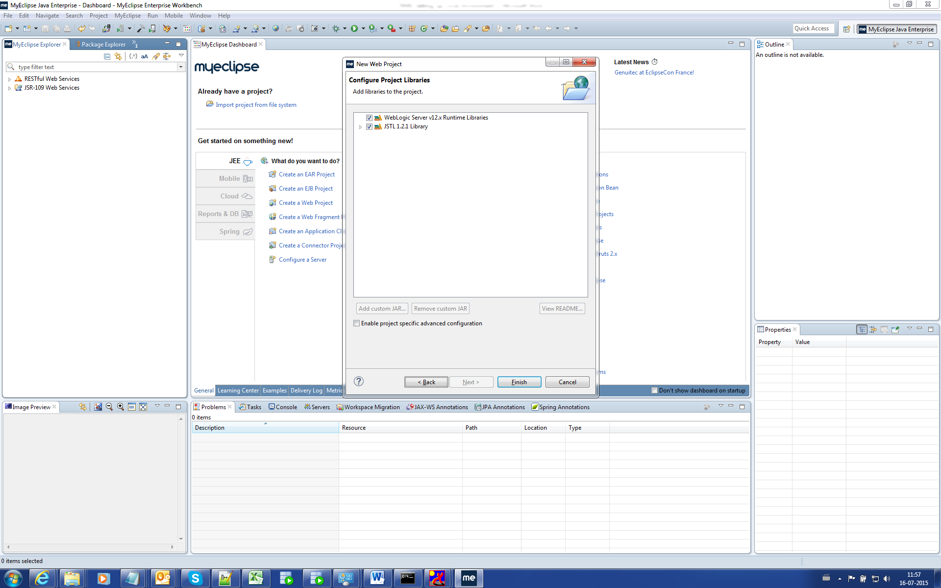

Click Finish.

Revoking Validation of JSP/JS/HTML

Check the “Suspend all validators” and click ok.

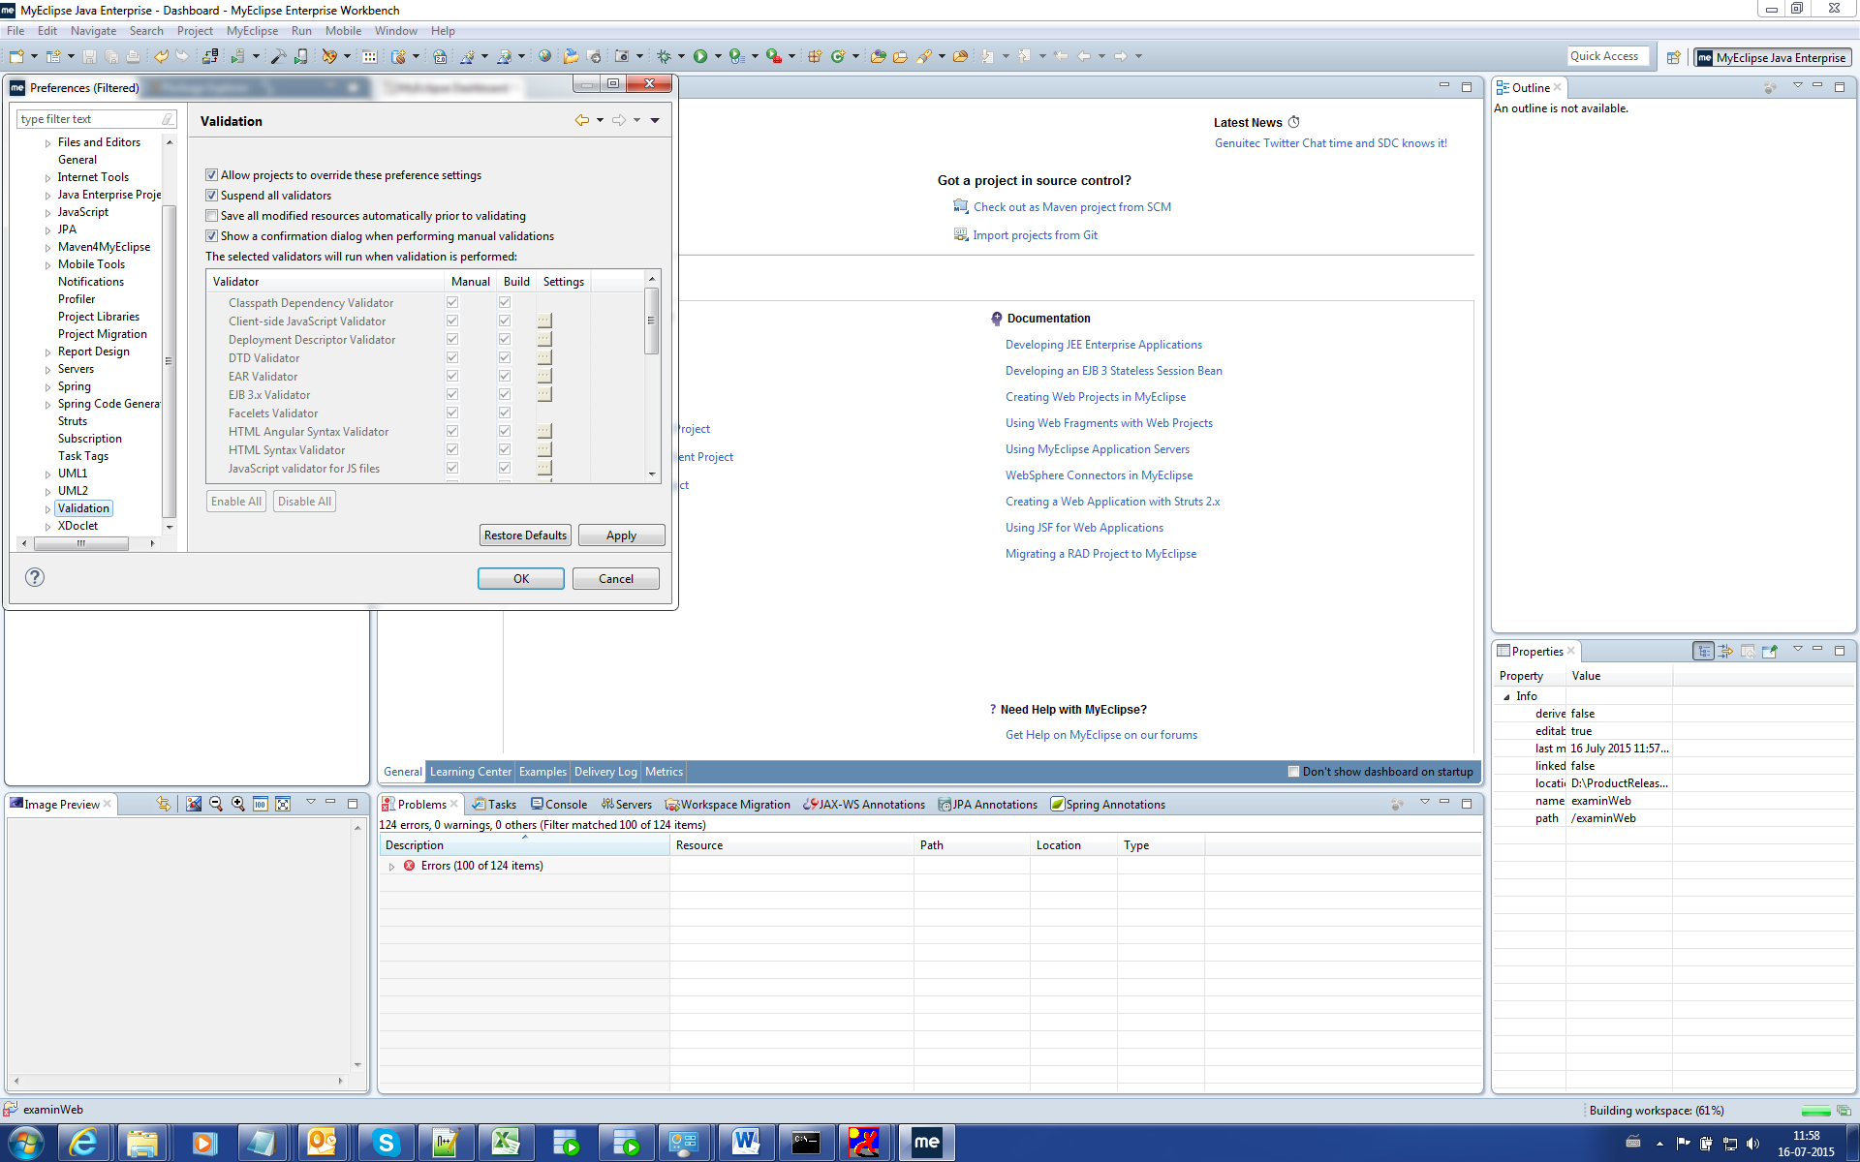

Adding required libraries.

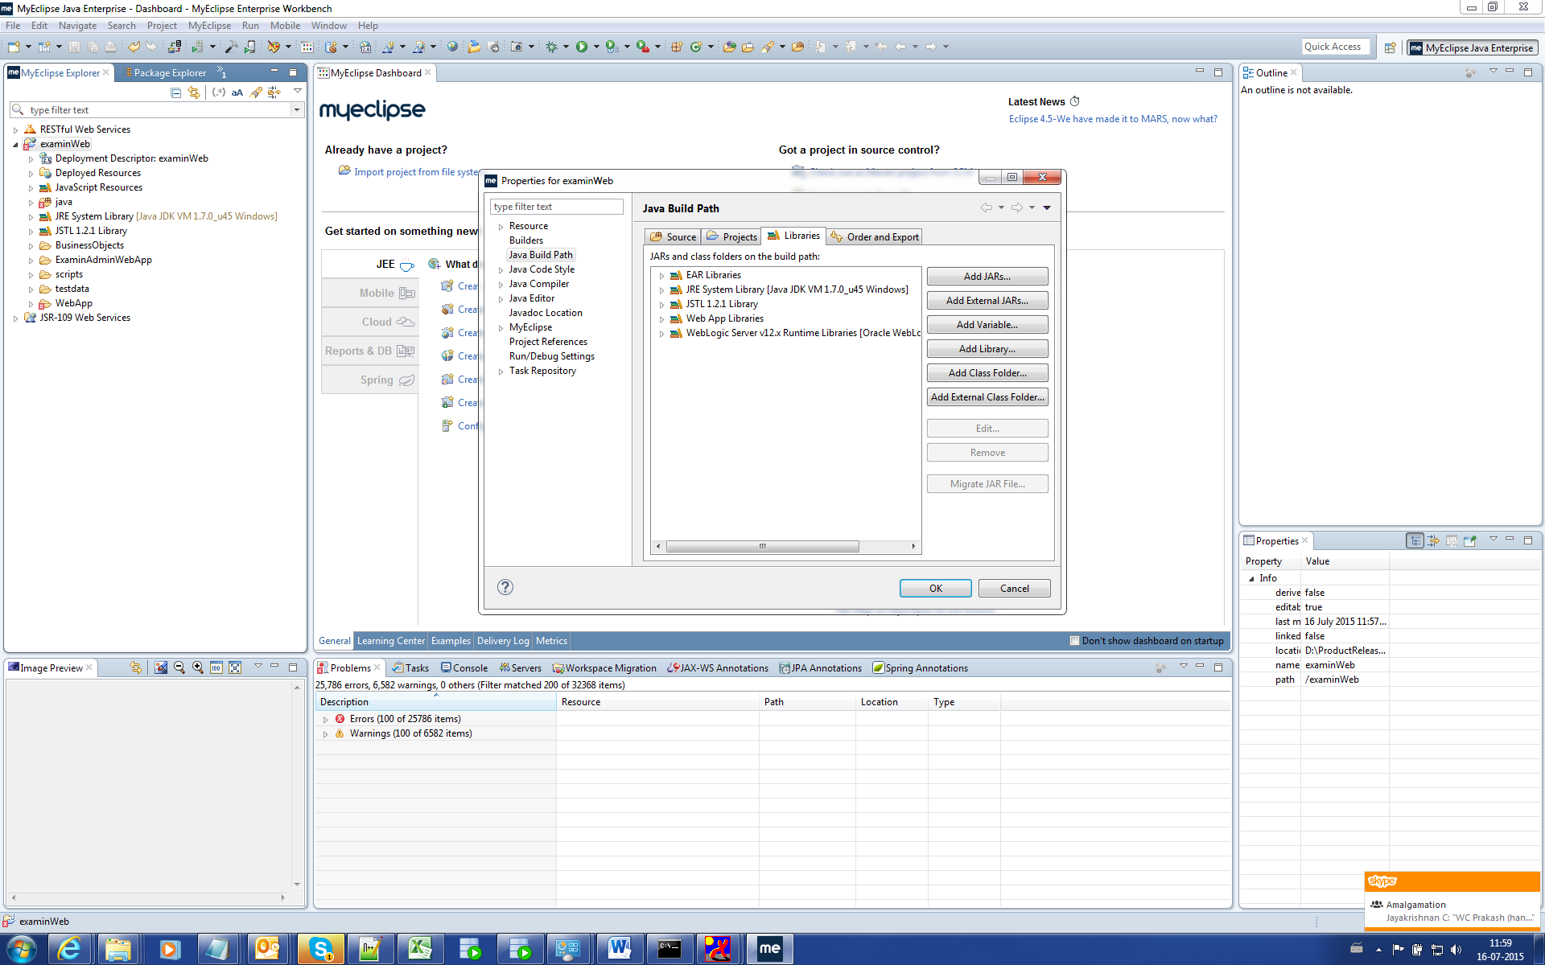

Add Library 🡪 MyEclipse Library 🡪 Next

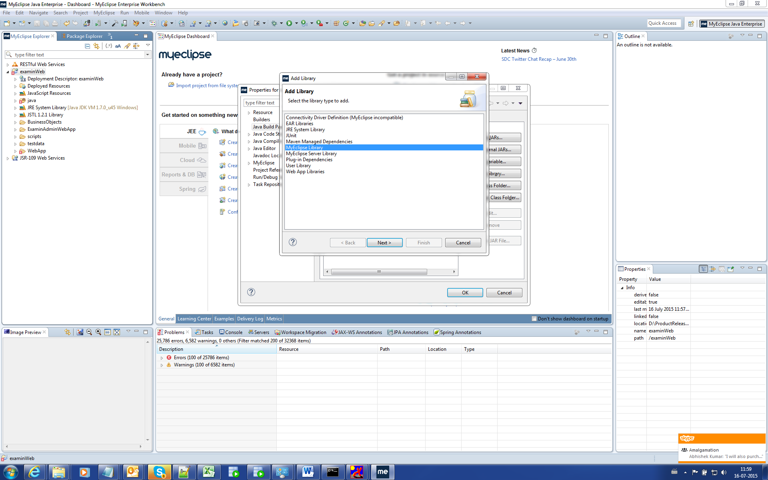

Search and Add JavaEE 6.0 Generic Library.

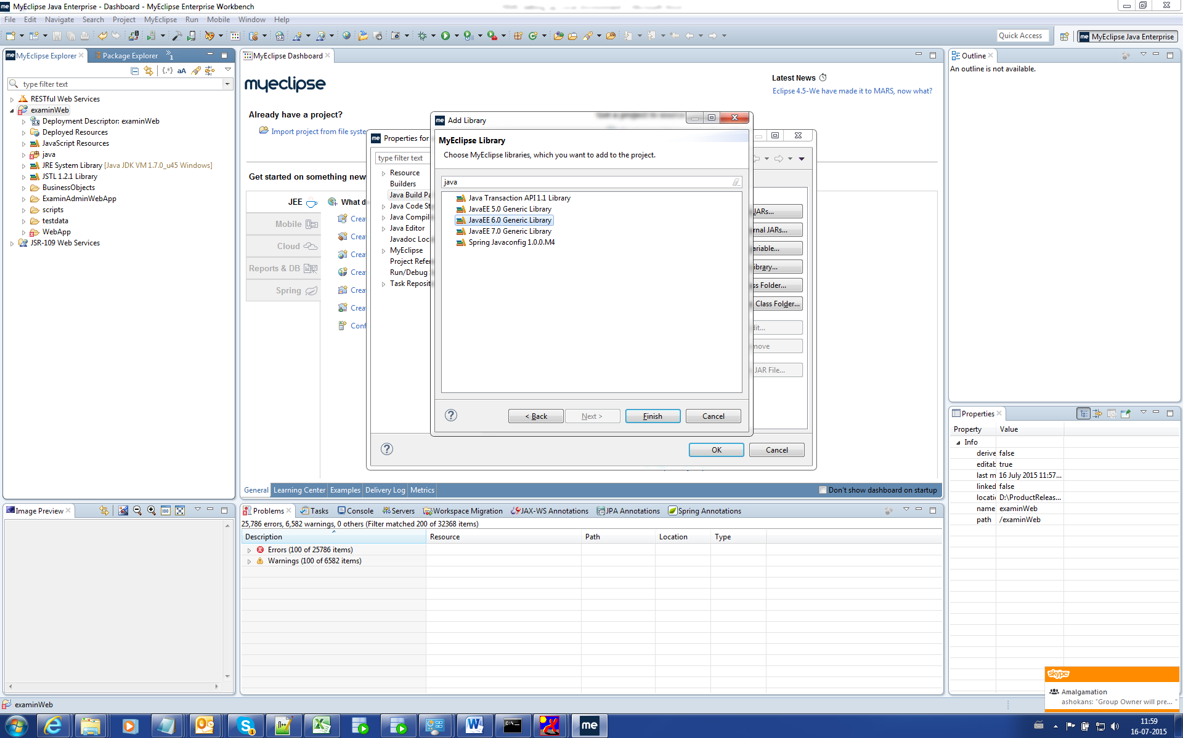

Click Finish.

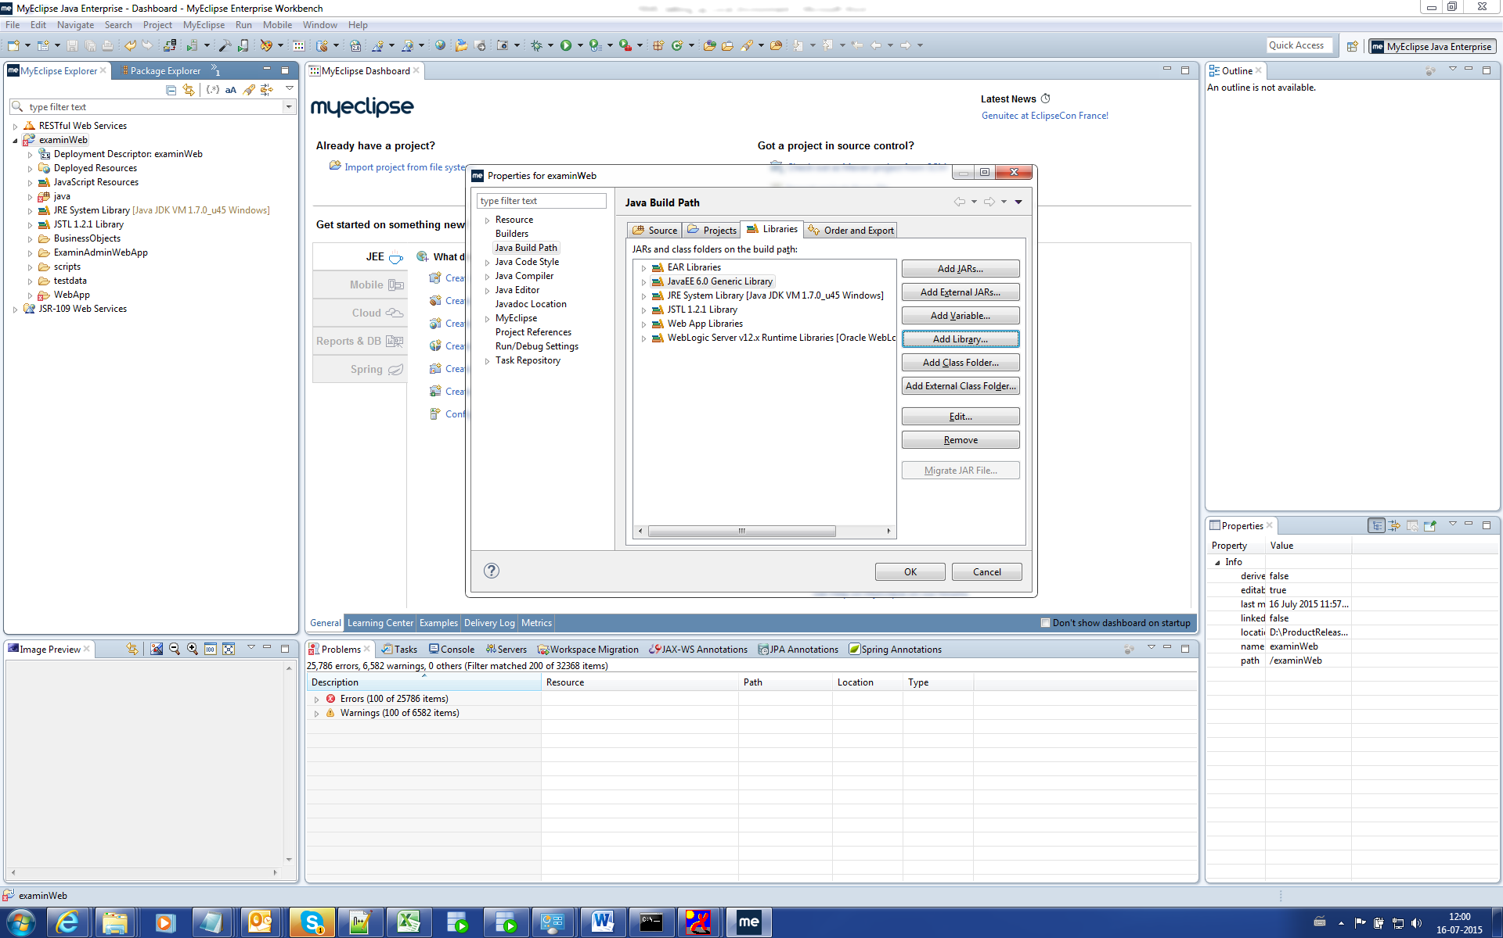

Click Ok.

Add Library 🡪 User Library.

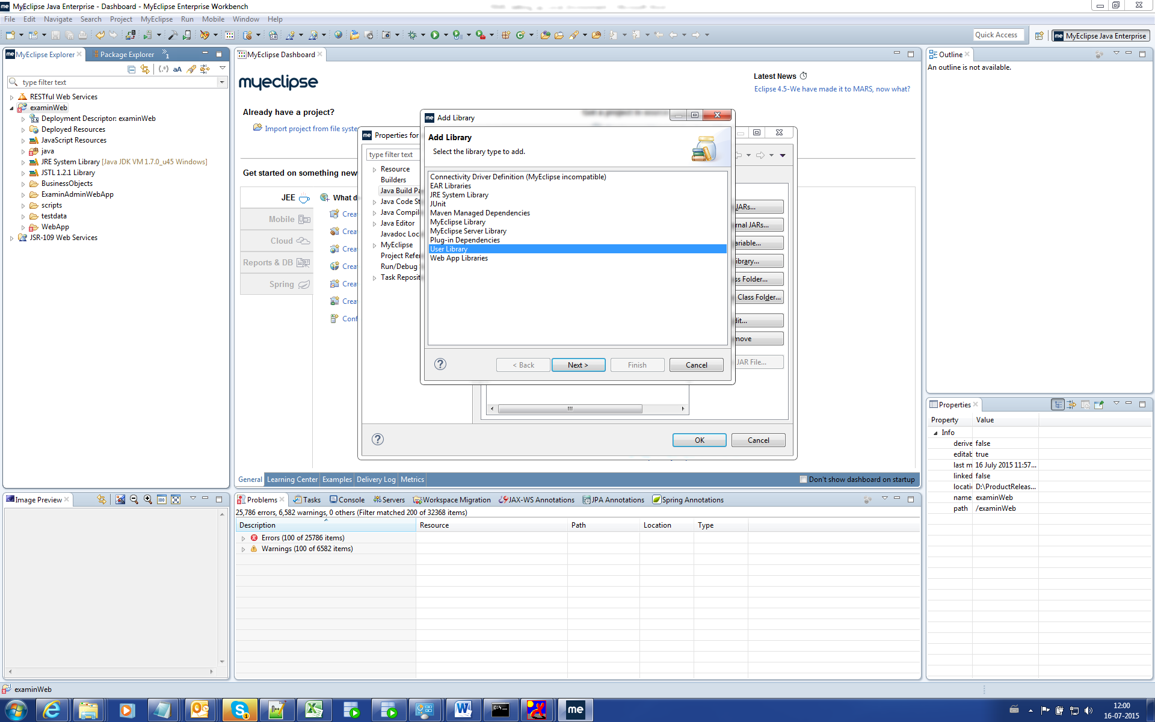

Click the User Libraries and Add

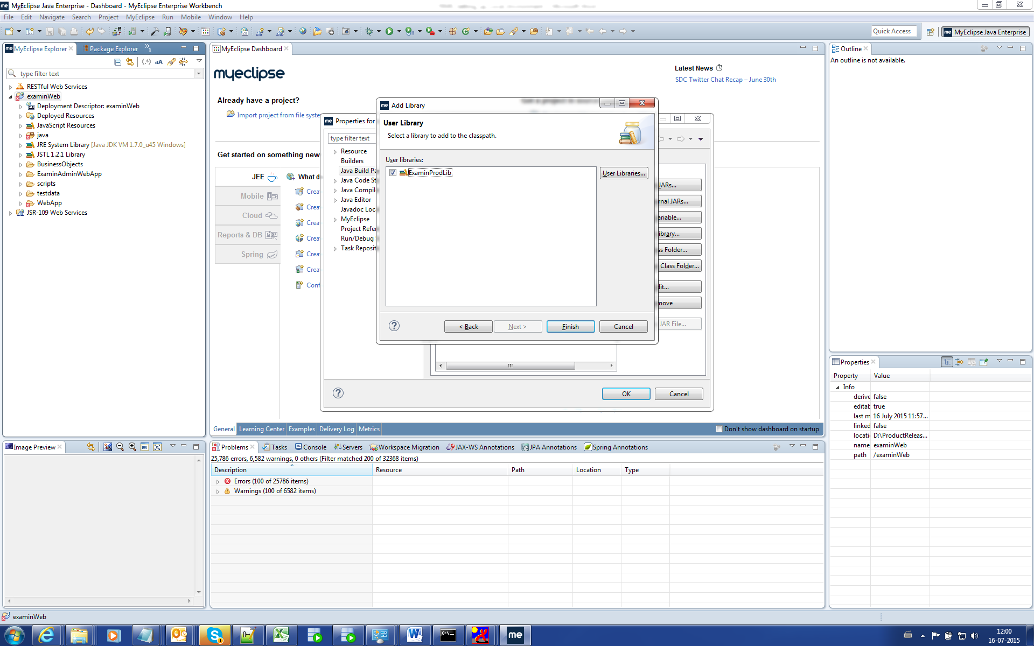

Add all Jar from the Production or Prototype source lib folder.

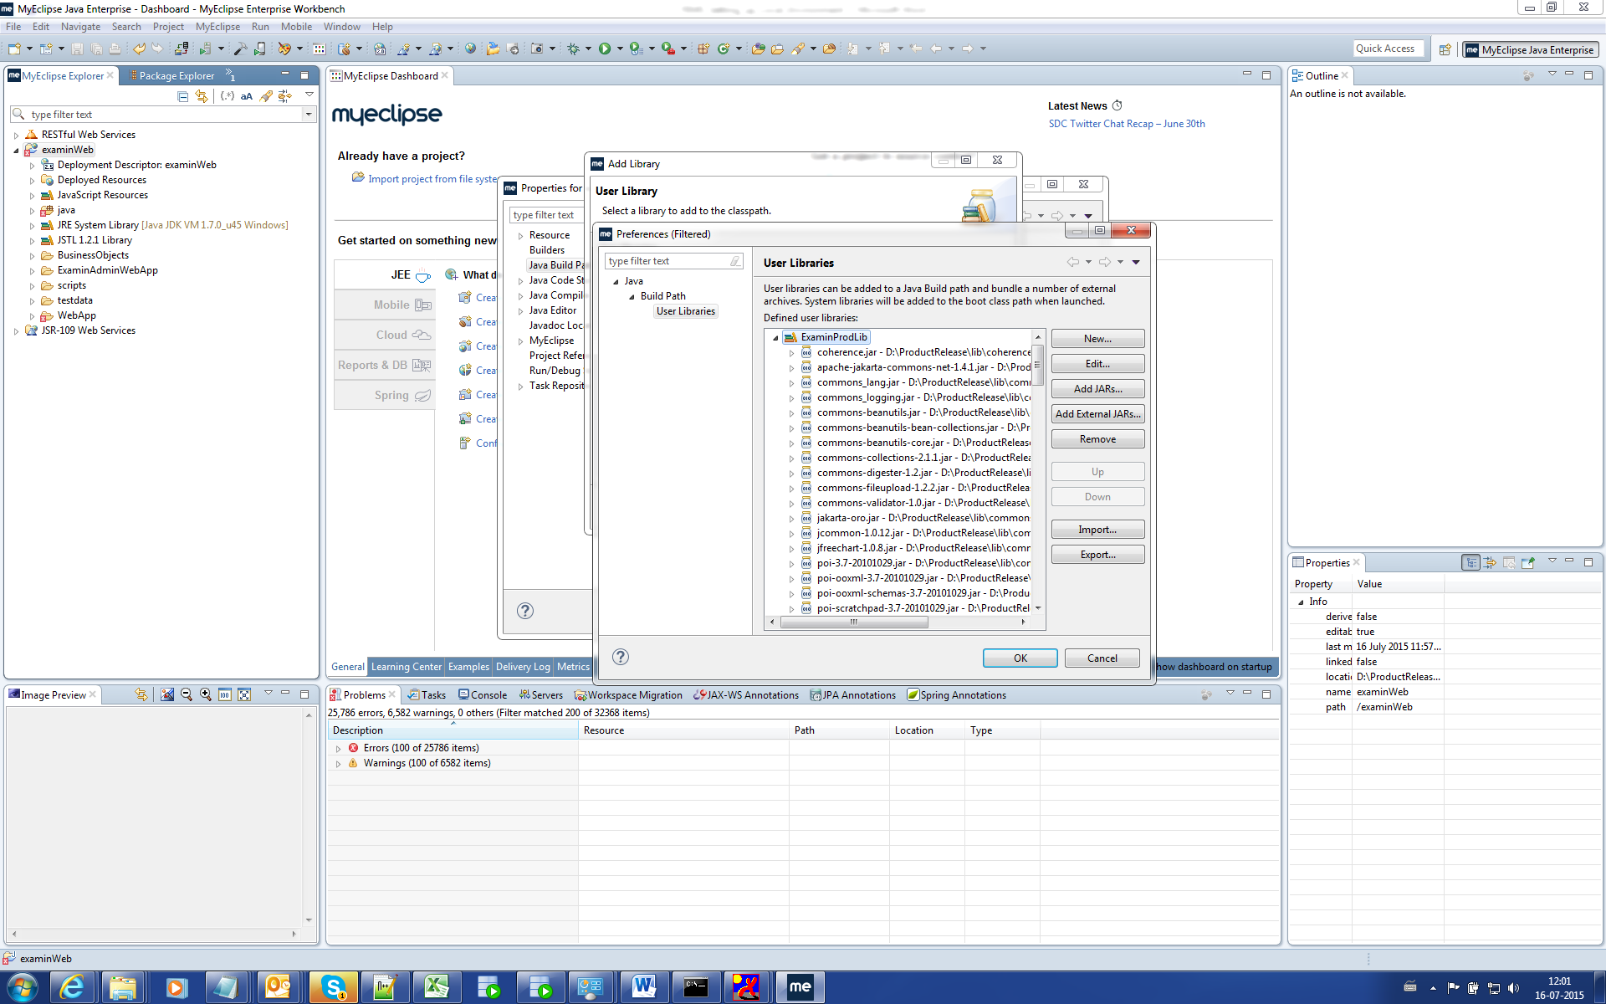

Click Ok.

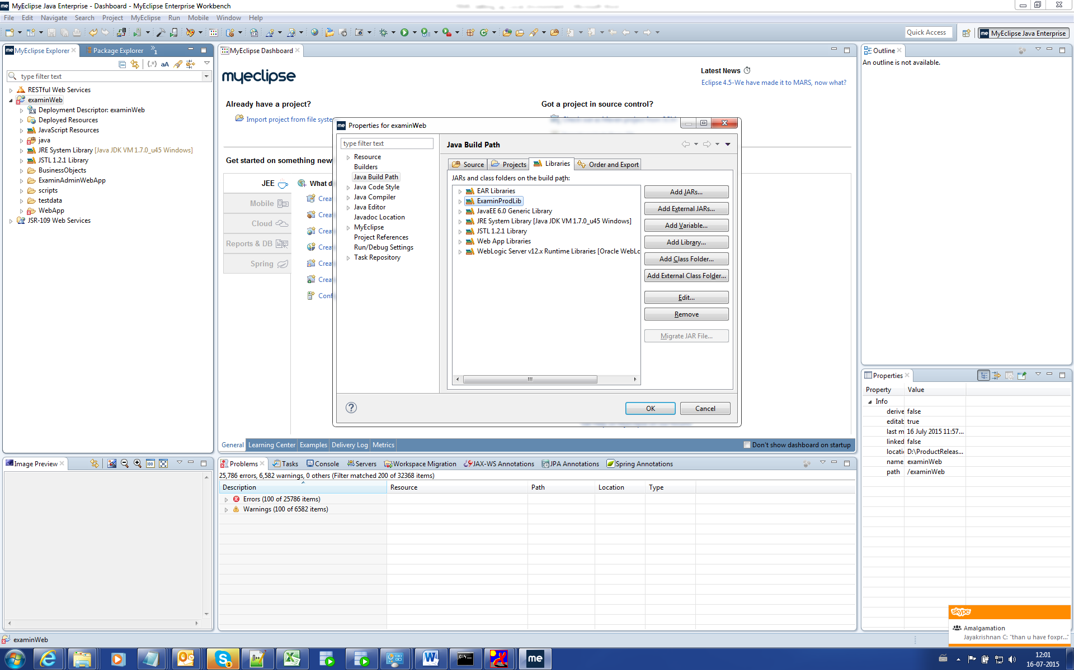

Click Ok.

# Server Setup

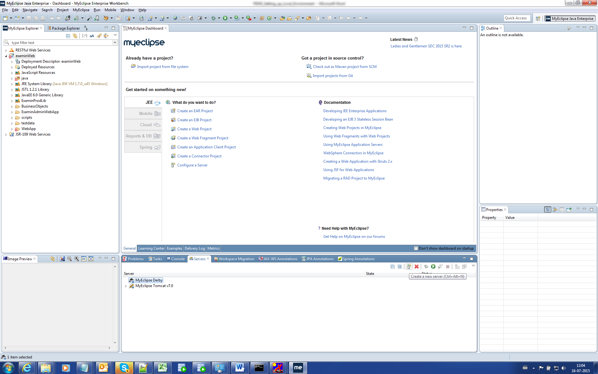

Right Click 🡪 New Servers

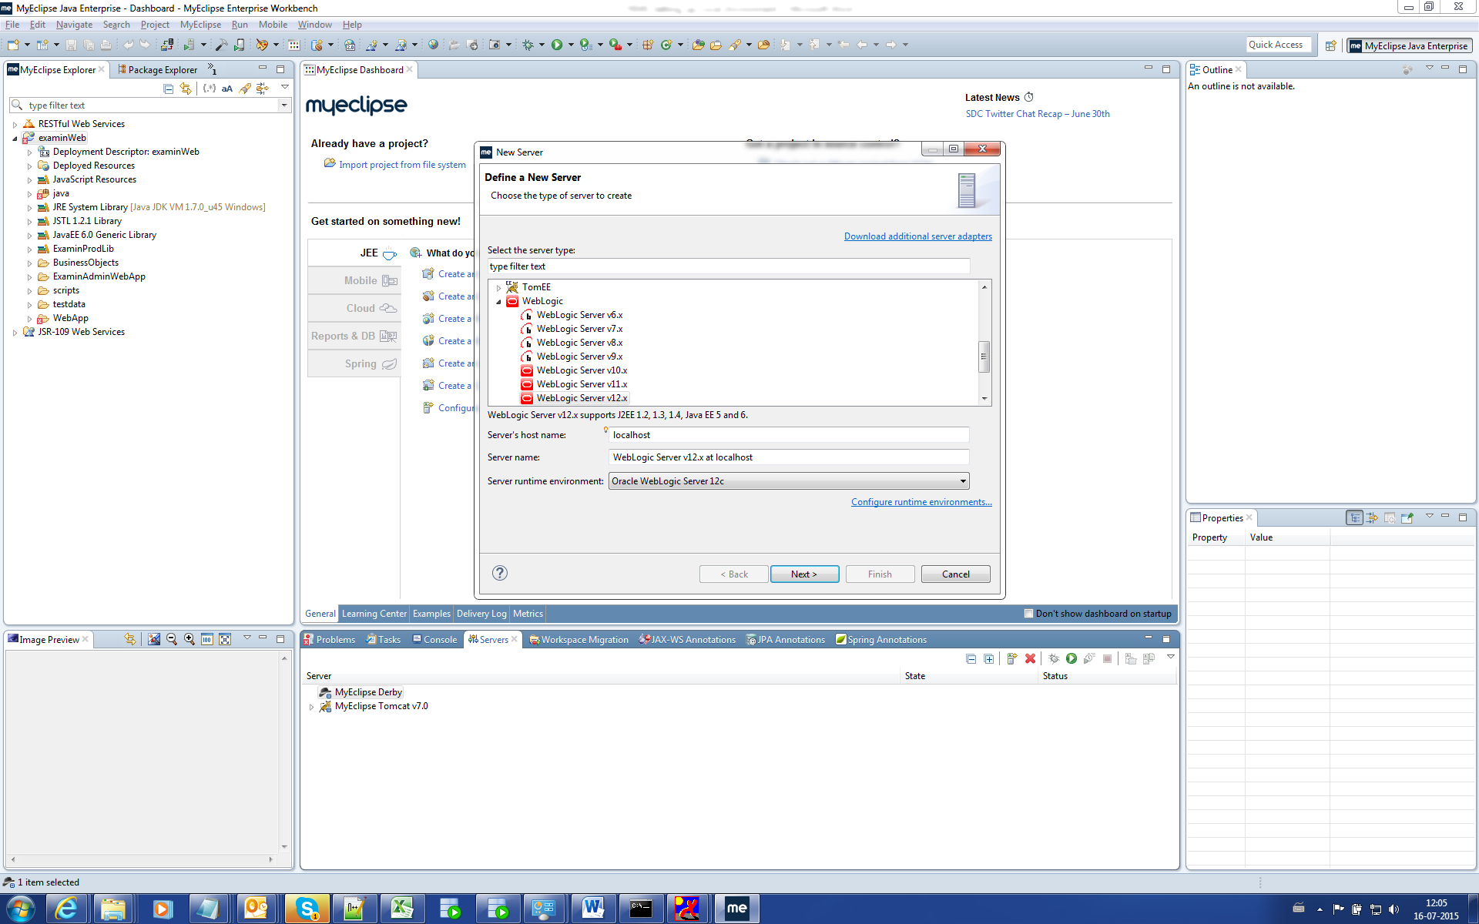

Administration username: weblogic

Administration password: ask asokan for the password.

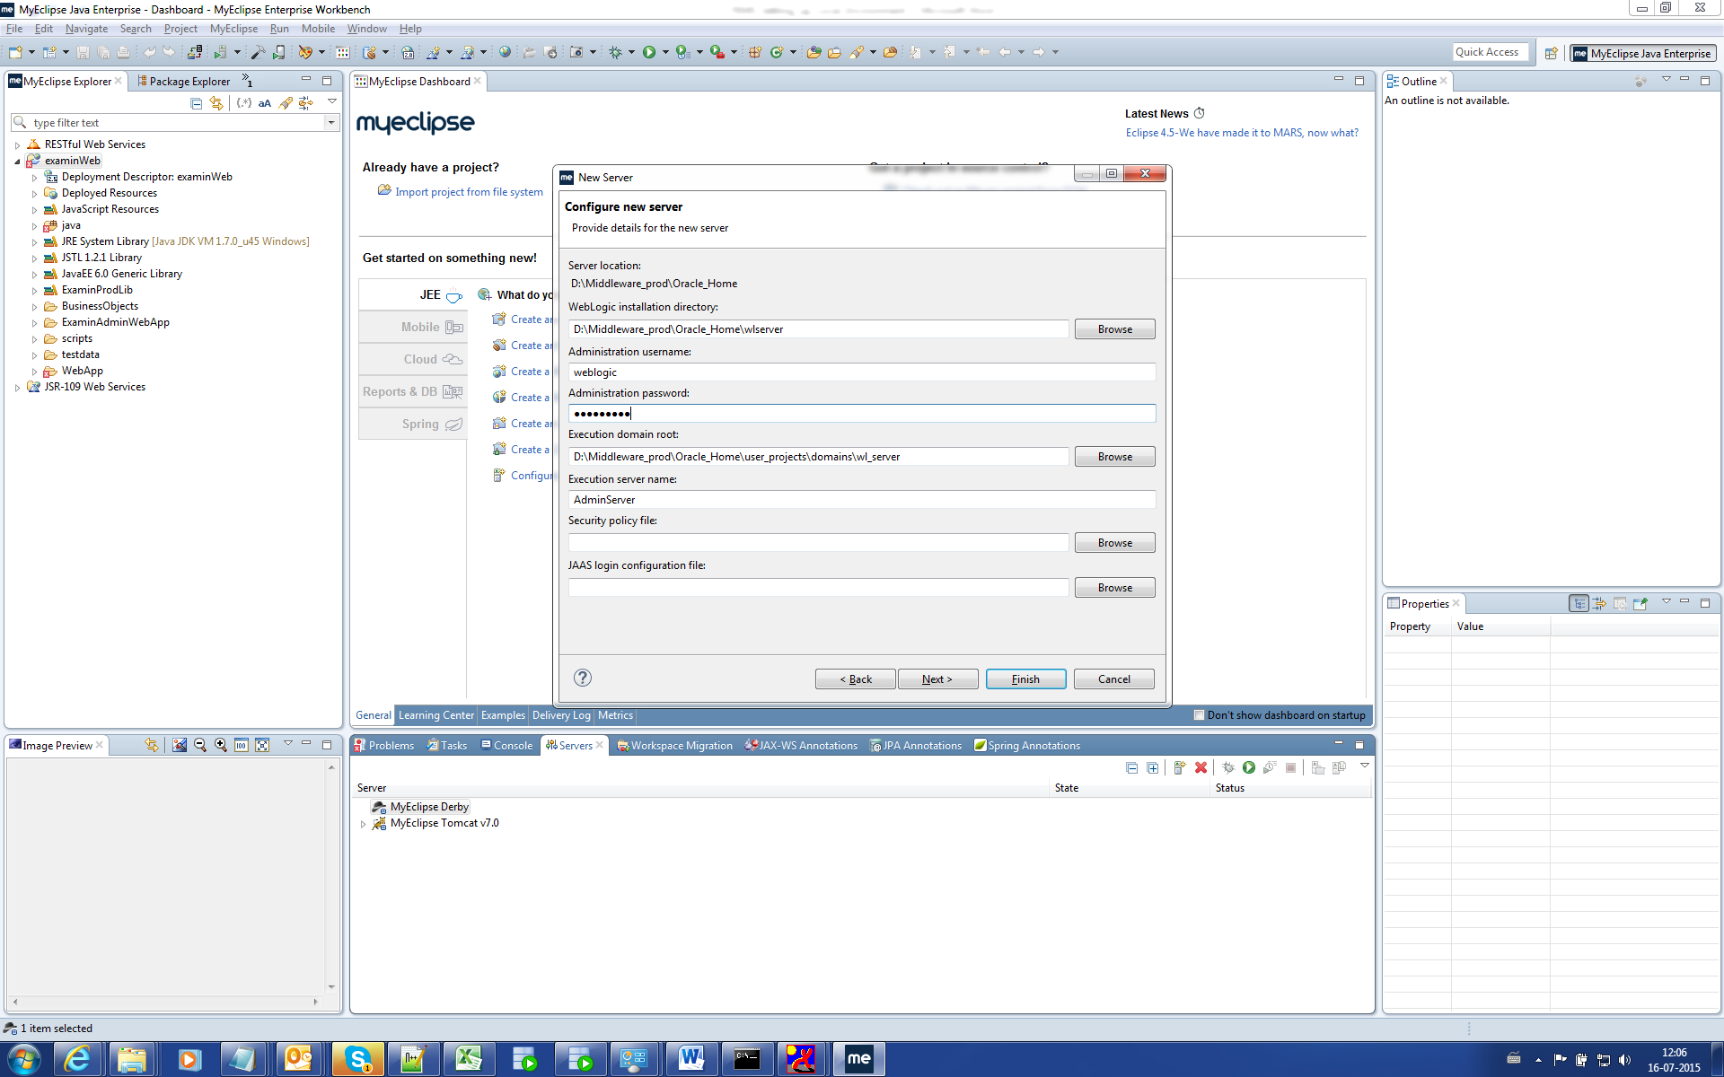

Click Next.

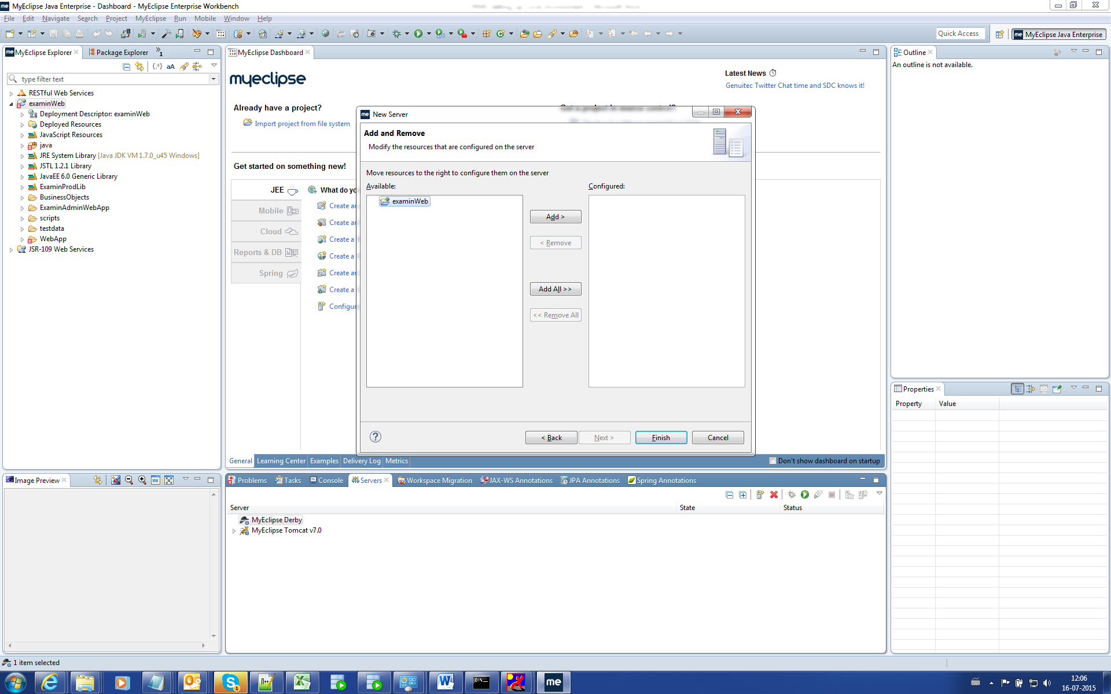

Select the Project and Add.

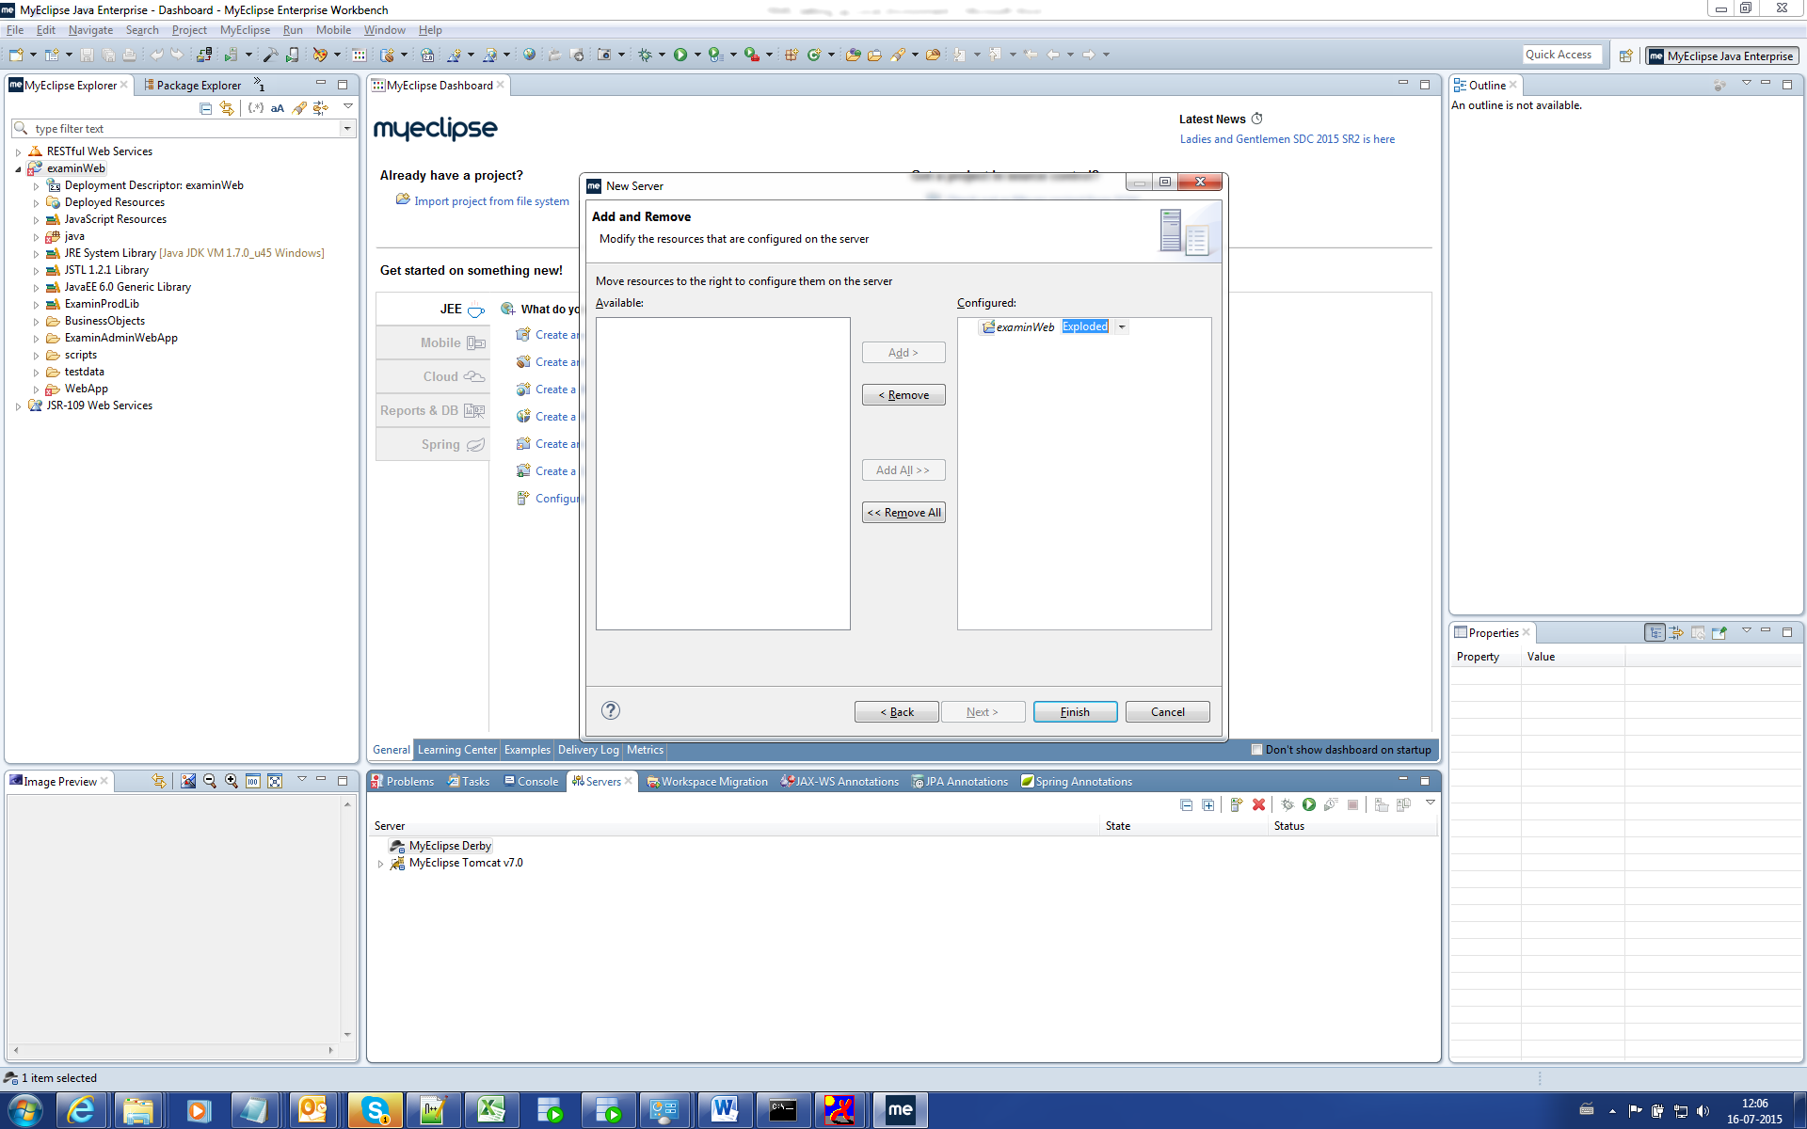

Click Finish.

Right Click on the Server and Open

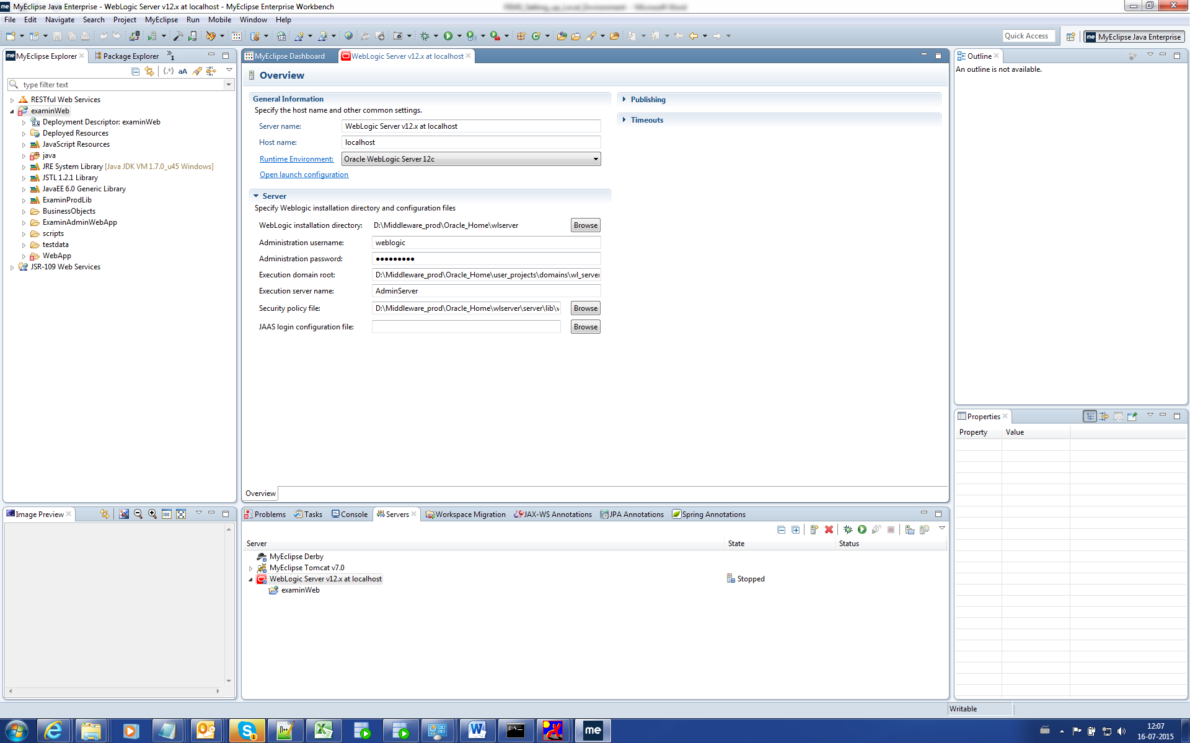

Click Open Launch Configuration

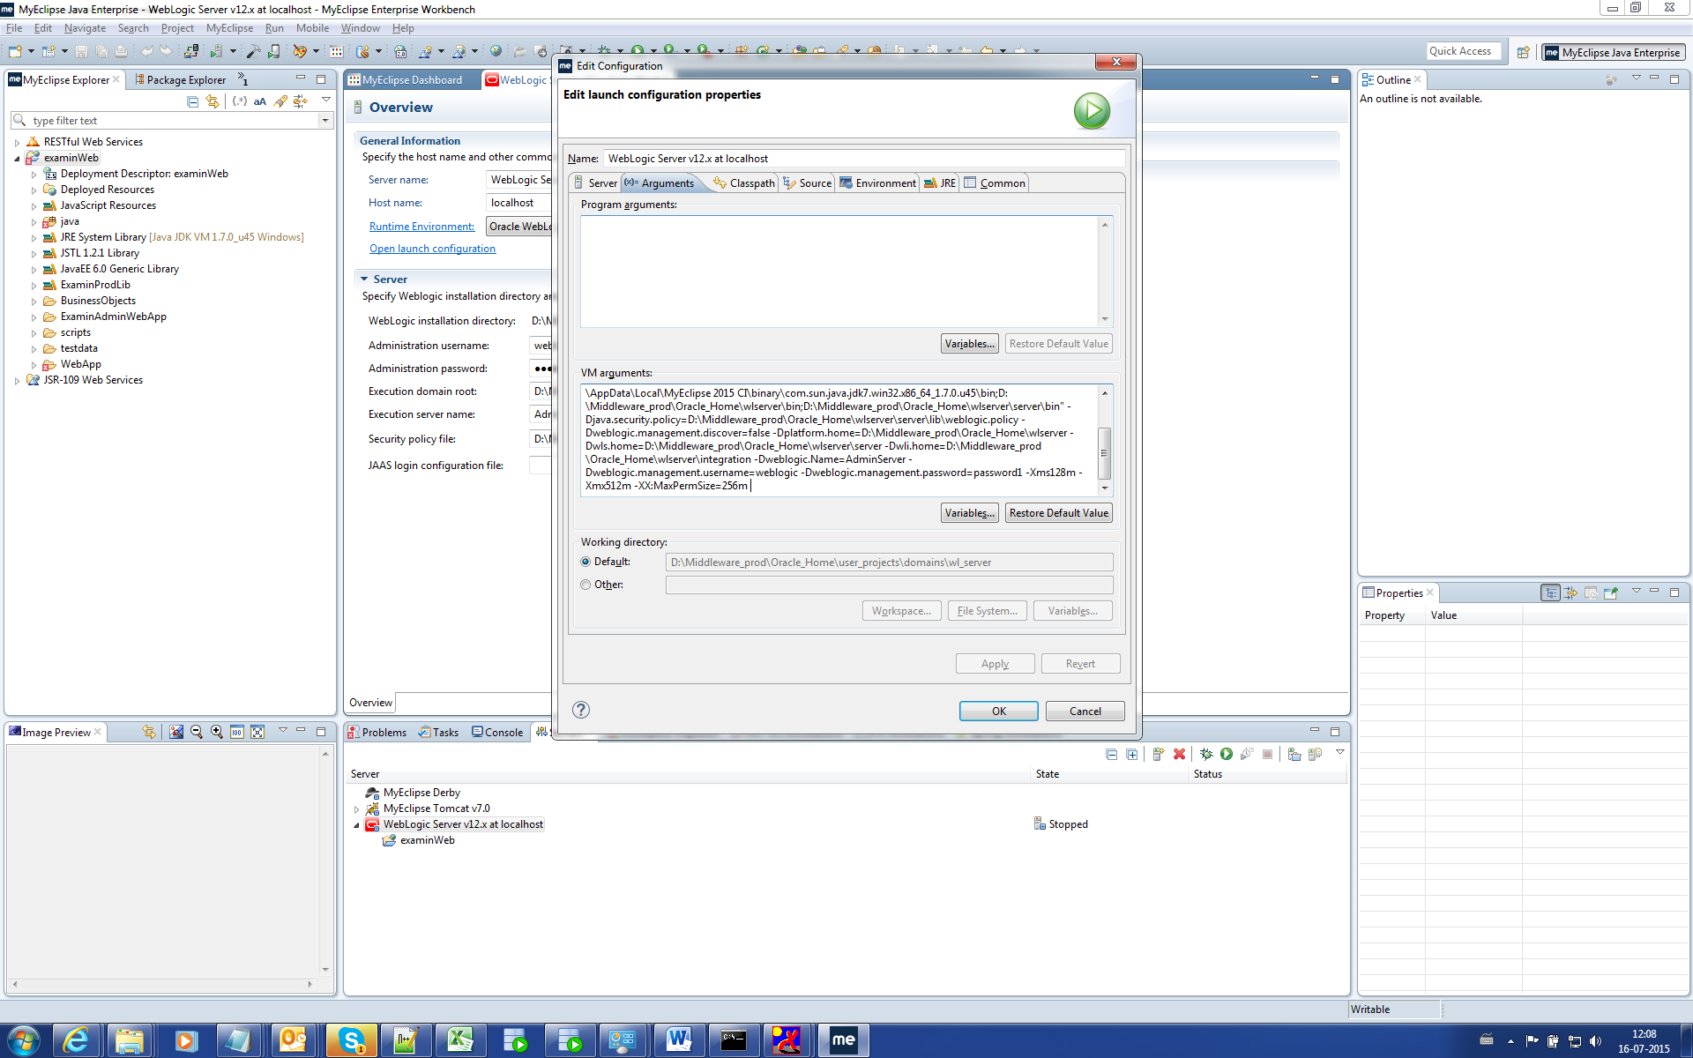

-Dcom.sun.xml.namespace.QName.useCompatibleSerialVersionUID=1.0 -Dinspire.config=examinconfig.xml -Dlog4j.rootCategory=DEBUG -Dlog4j.configuration=log4j.properties -noverify -DwebEnv=AsokanLocal -DrelVer=1.0.40 -noverify

-Dtangosol.coherence.cacheconfig=coherence-cache.xml -Dweblogic.PosixSocketReaders=20

For DB environment, add the following parameters

Append the above arguments in the VM arguments.

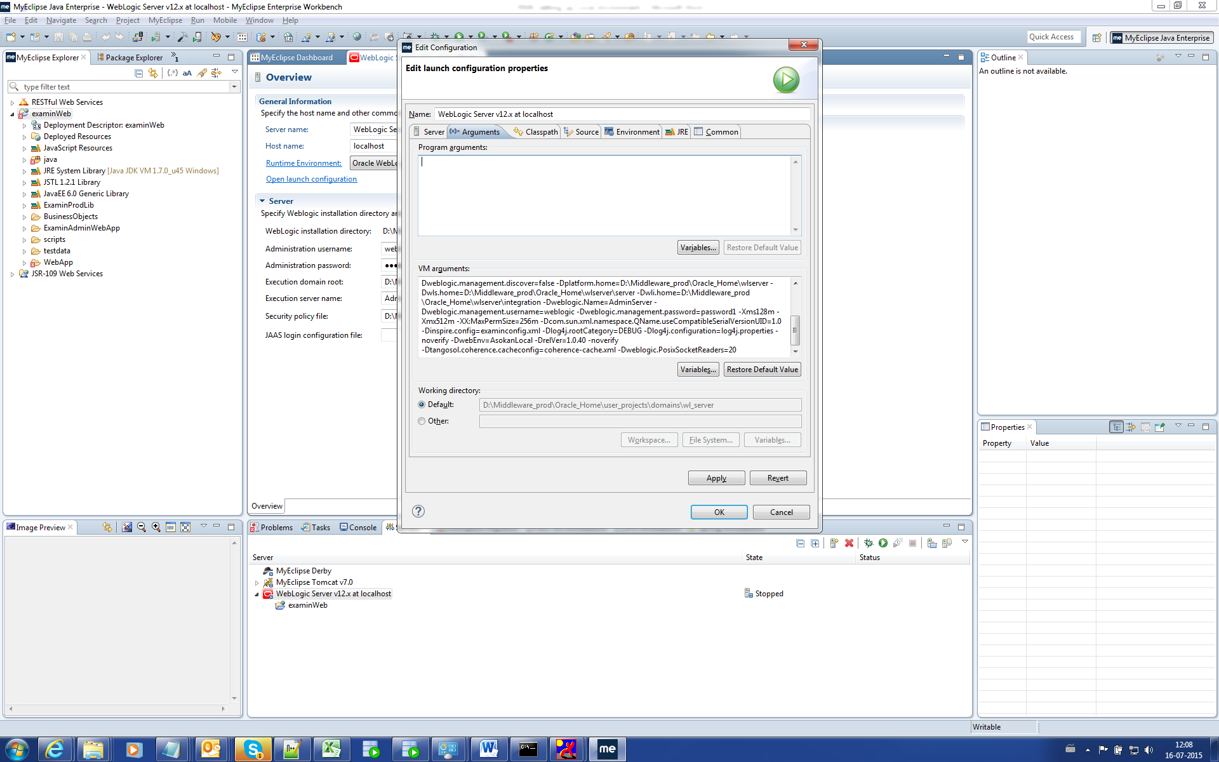

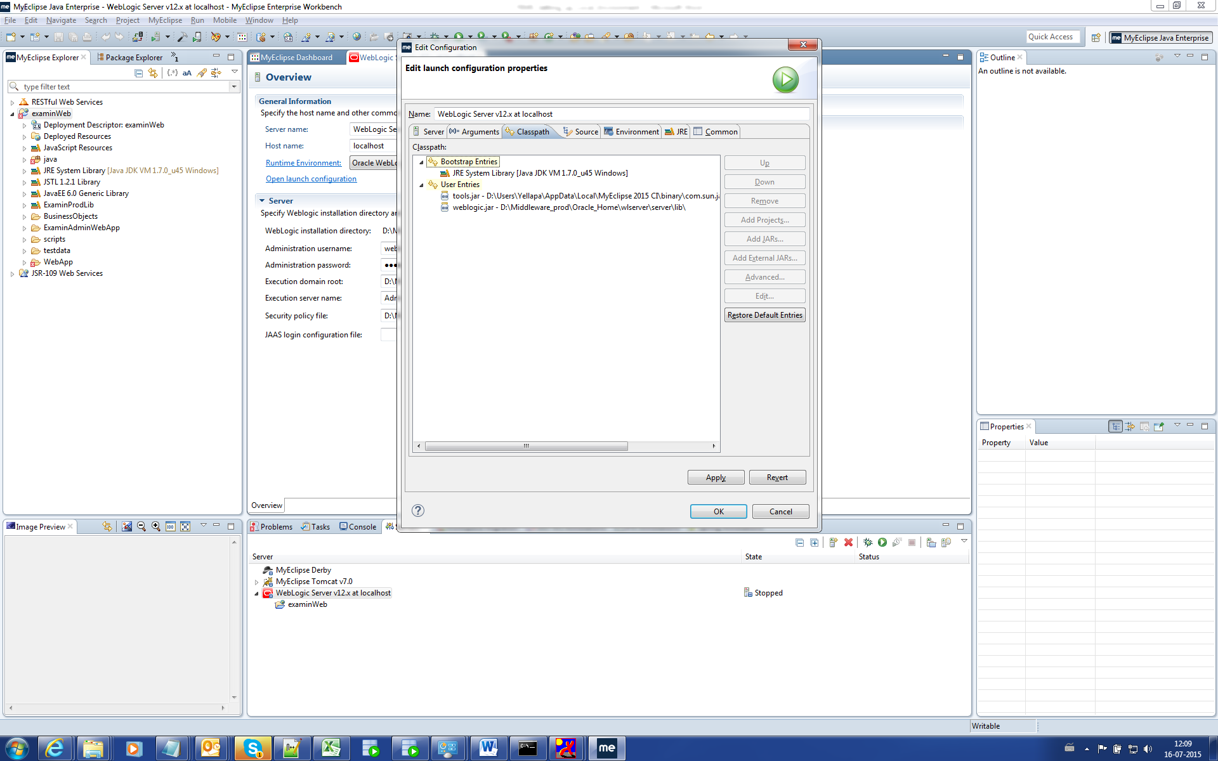

Add all Jar files in the Classpath (Jar file should be taken from the lib folder).

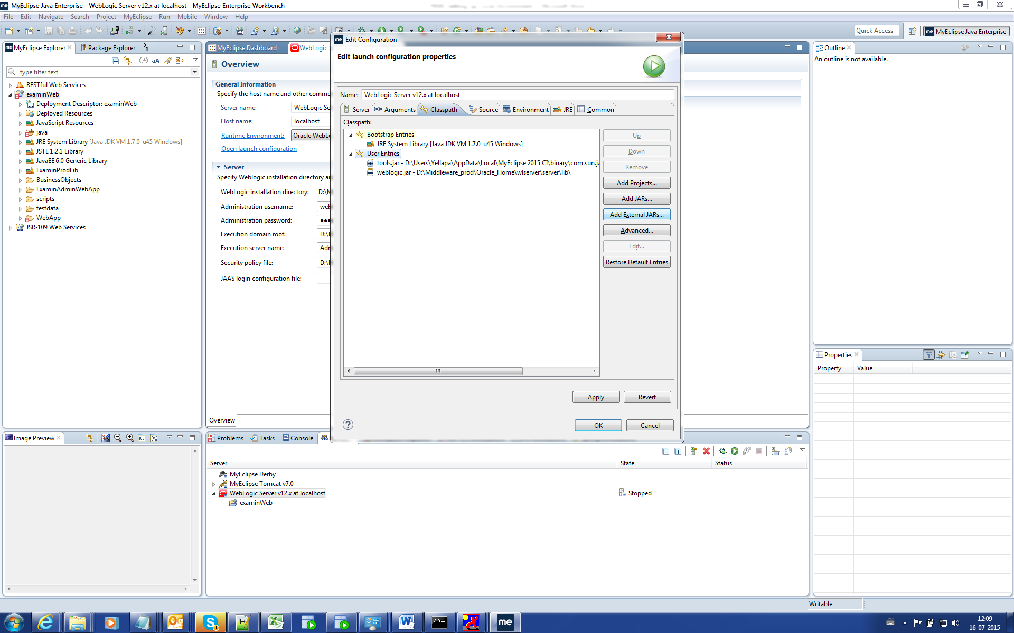

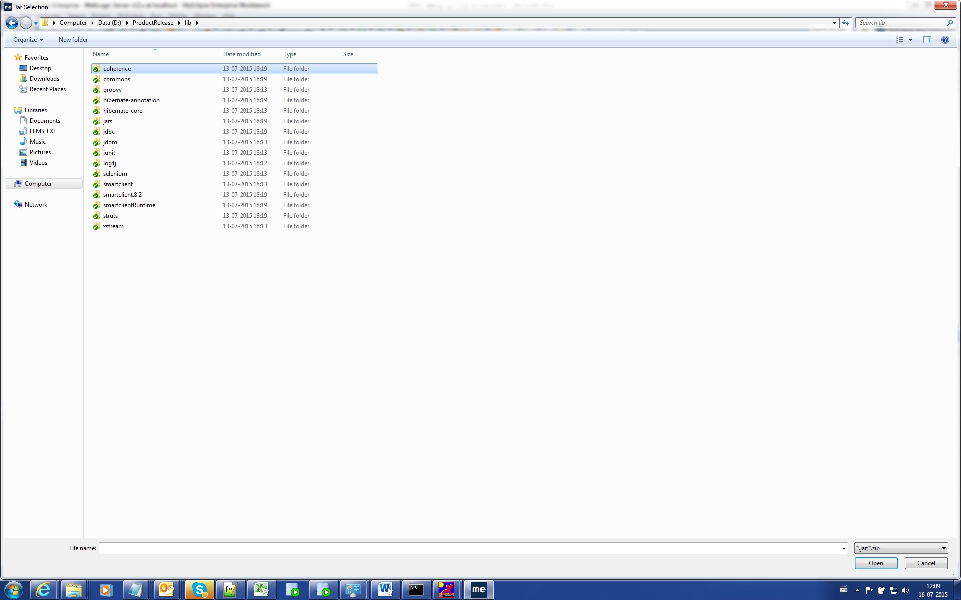

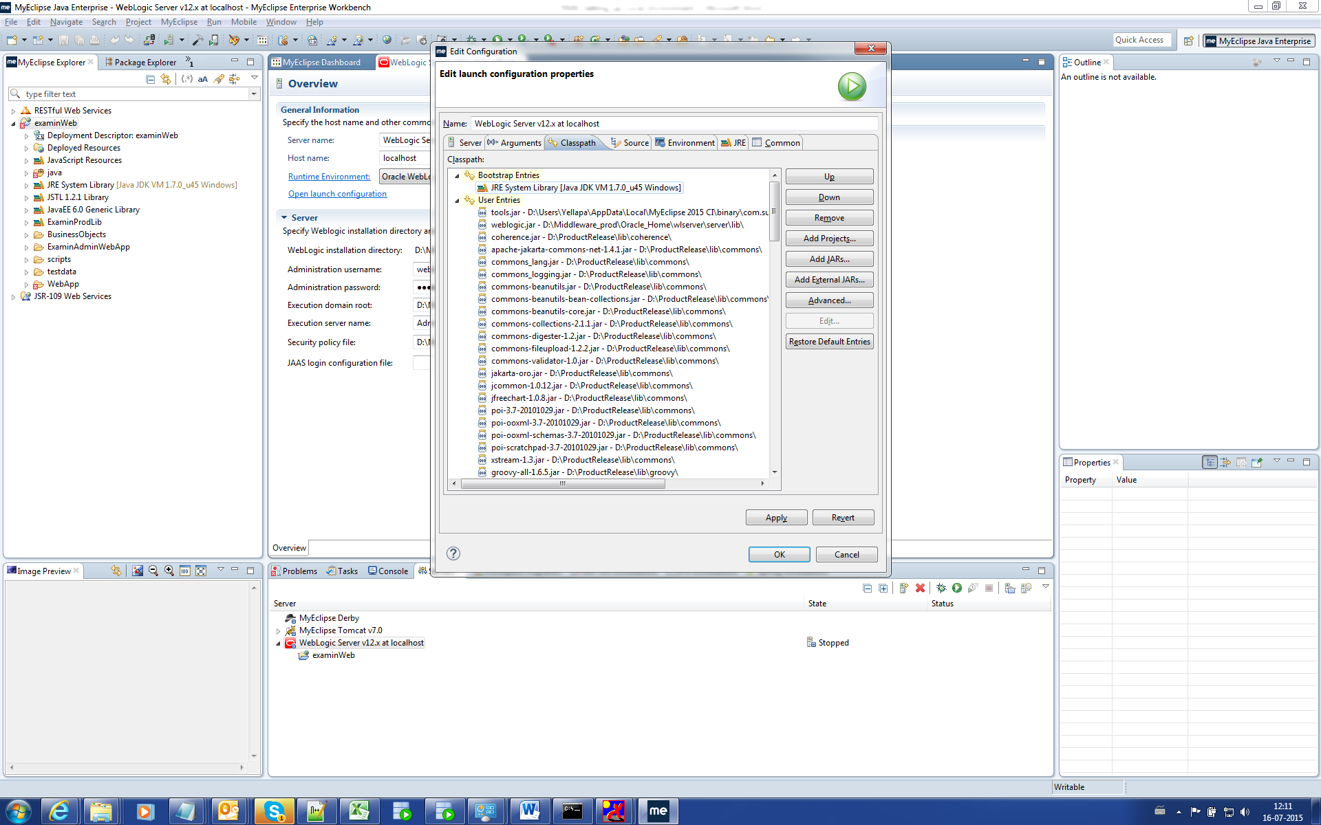

Click Apply and Ok.

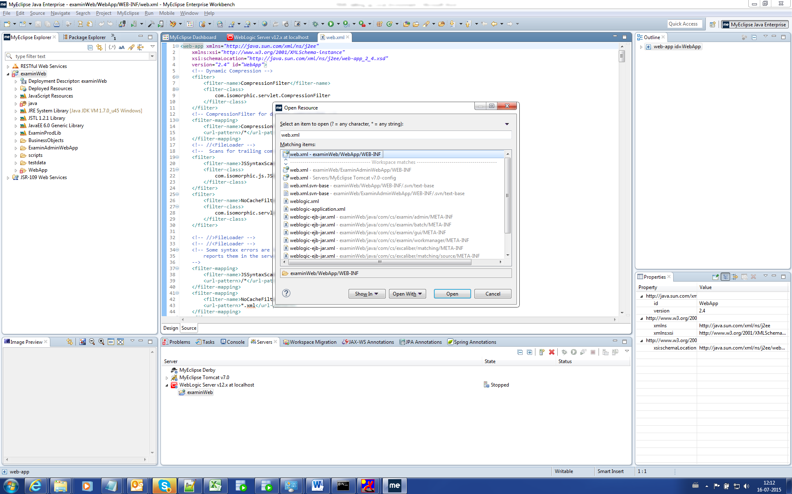

Open the web.xml

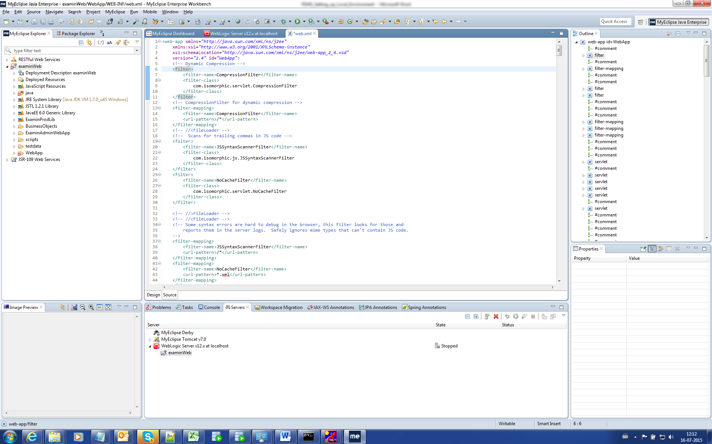

Comments the line as mentioned below.

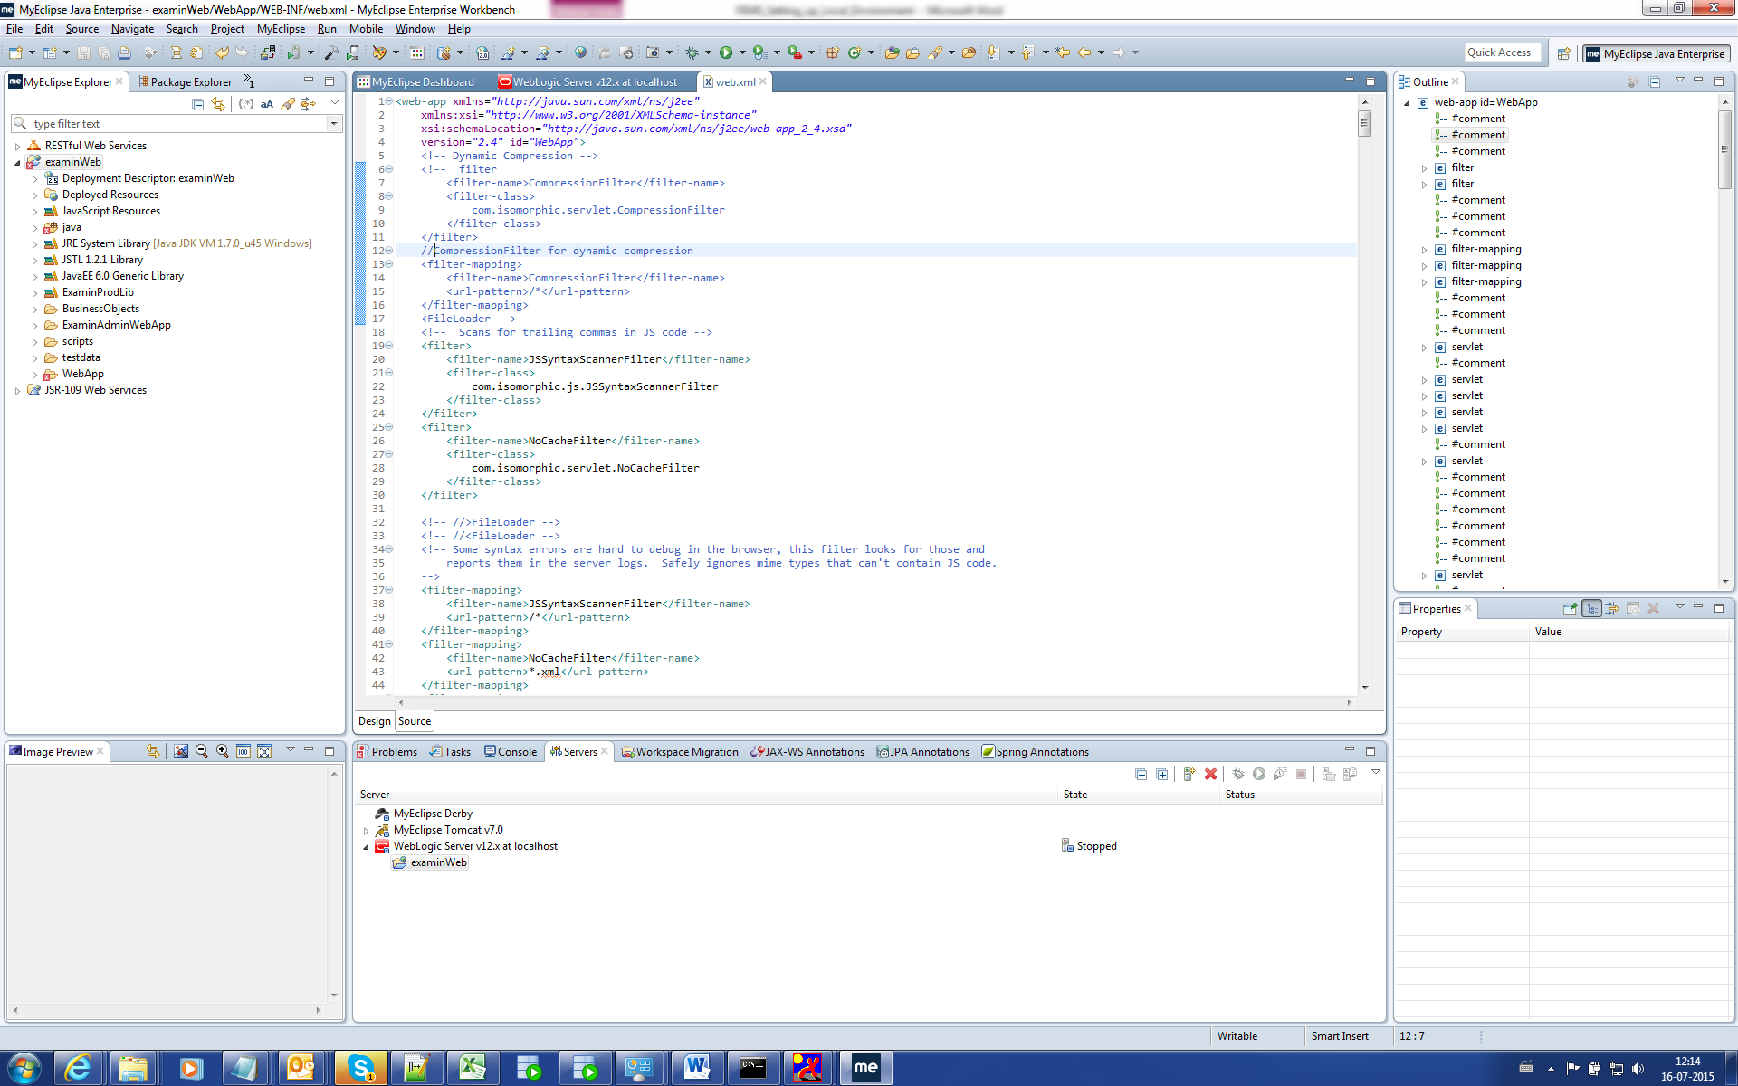

Open hibernate.cfg.xml file.

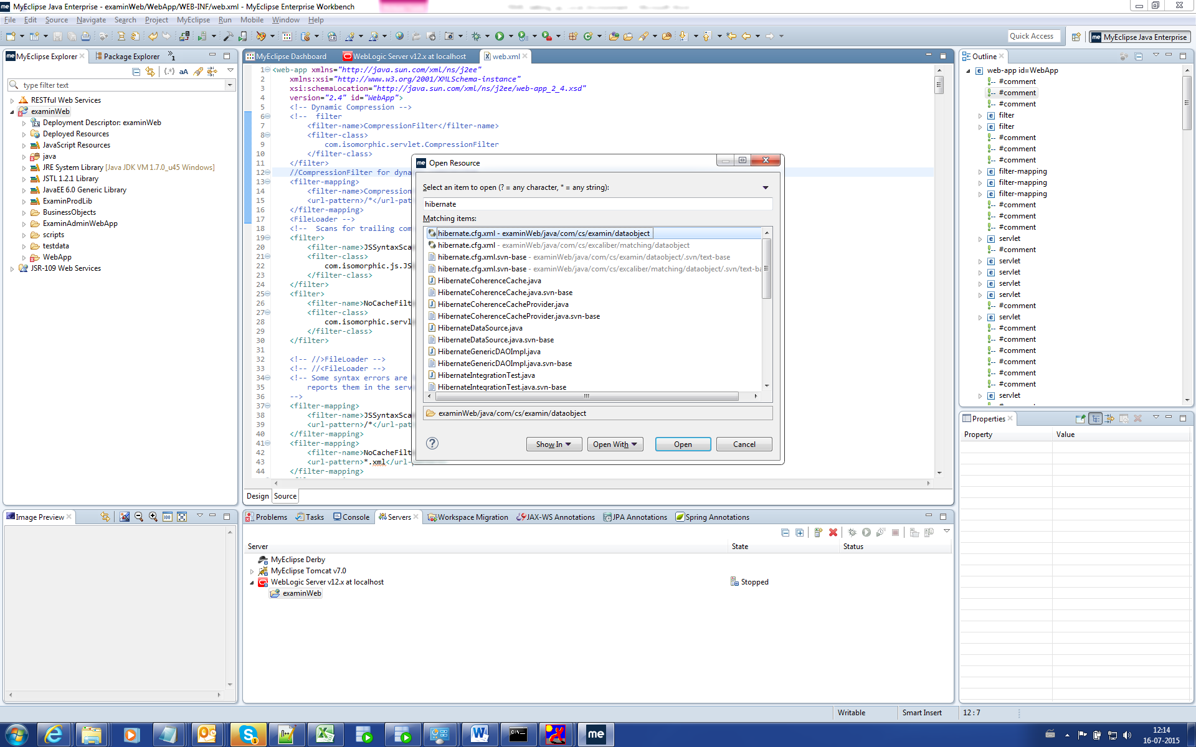

Change the property as “true”.

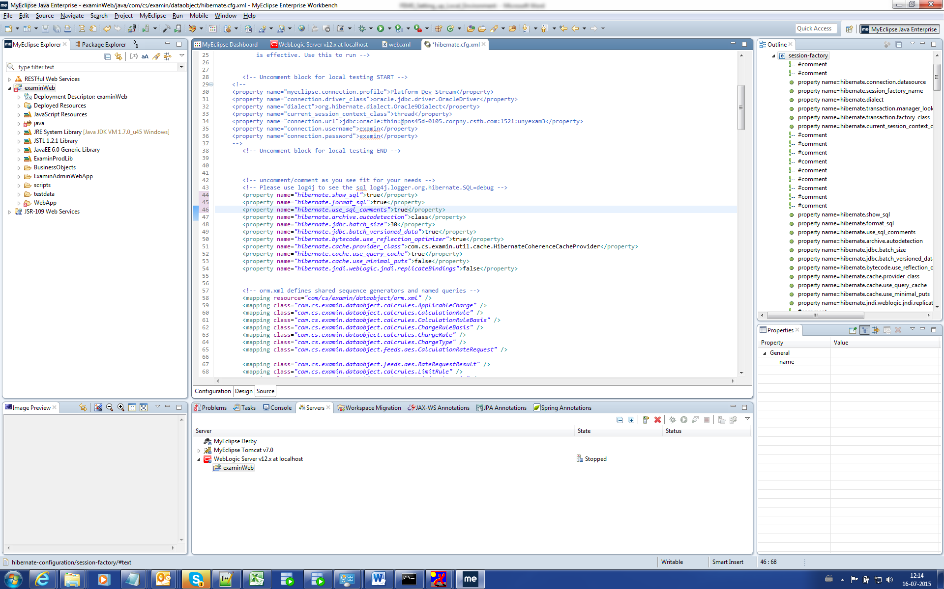

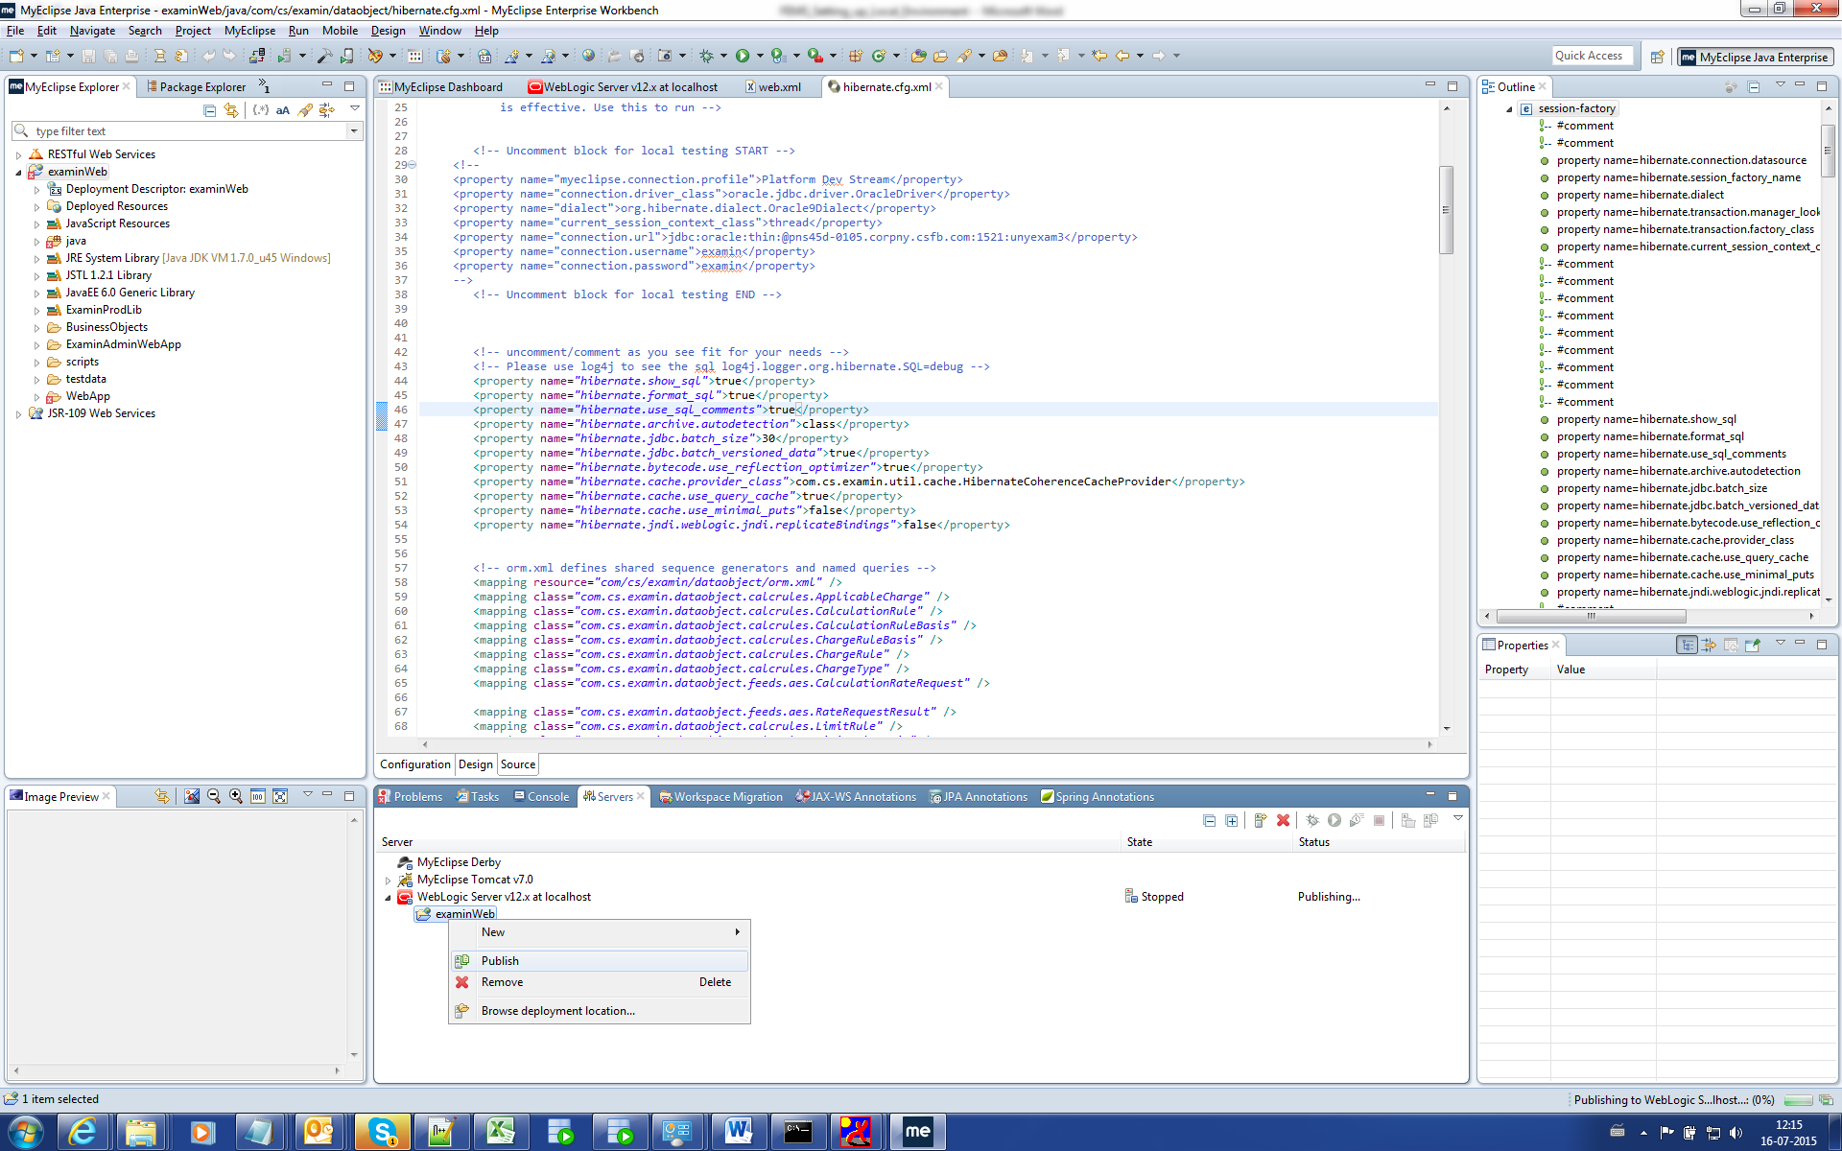

Right click on the Project and Publish.

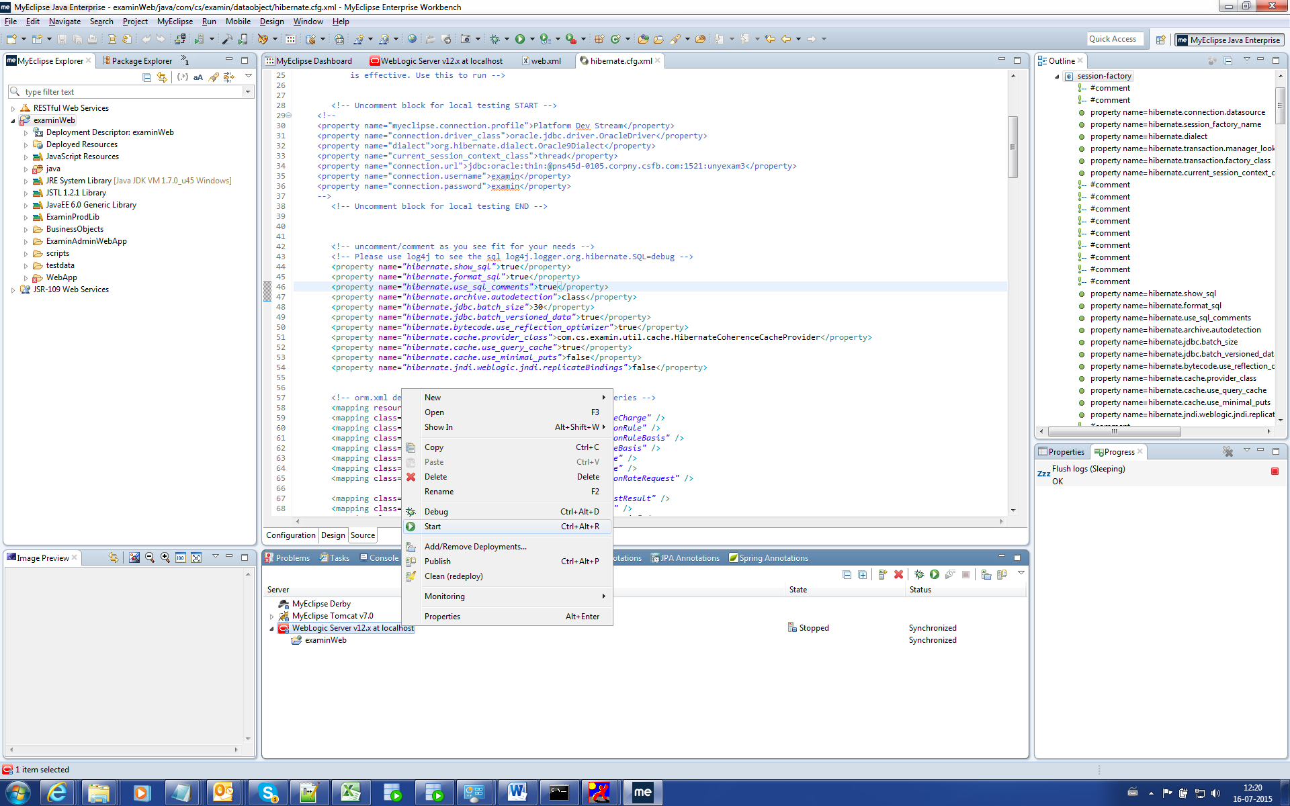

Start the Servers and should get the below lines in the console.

<16 Jul, 2015 12:23:46 PM IST> <Notice> <WebLogicServer> <BEA-000360> <The server started in RUNNING mode.>

<16 Jul, 2015 12:23:46 PM IST> <Notice> <WebLogicServer> <BEA-000365> <Server state changed to RUNNING.>

<http://localhost:7001/console>

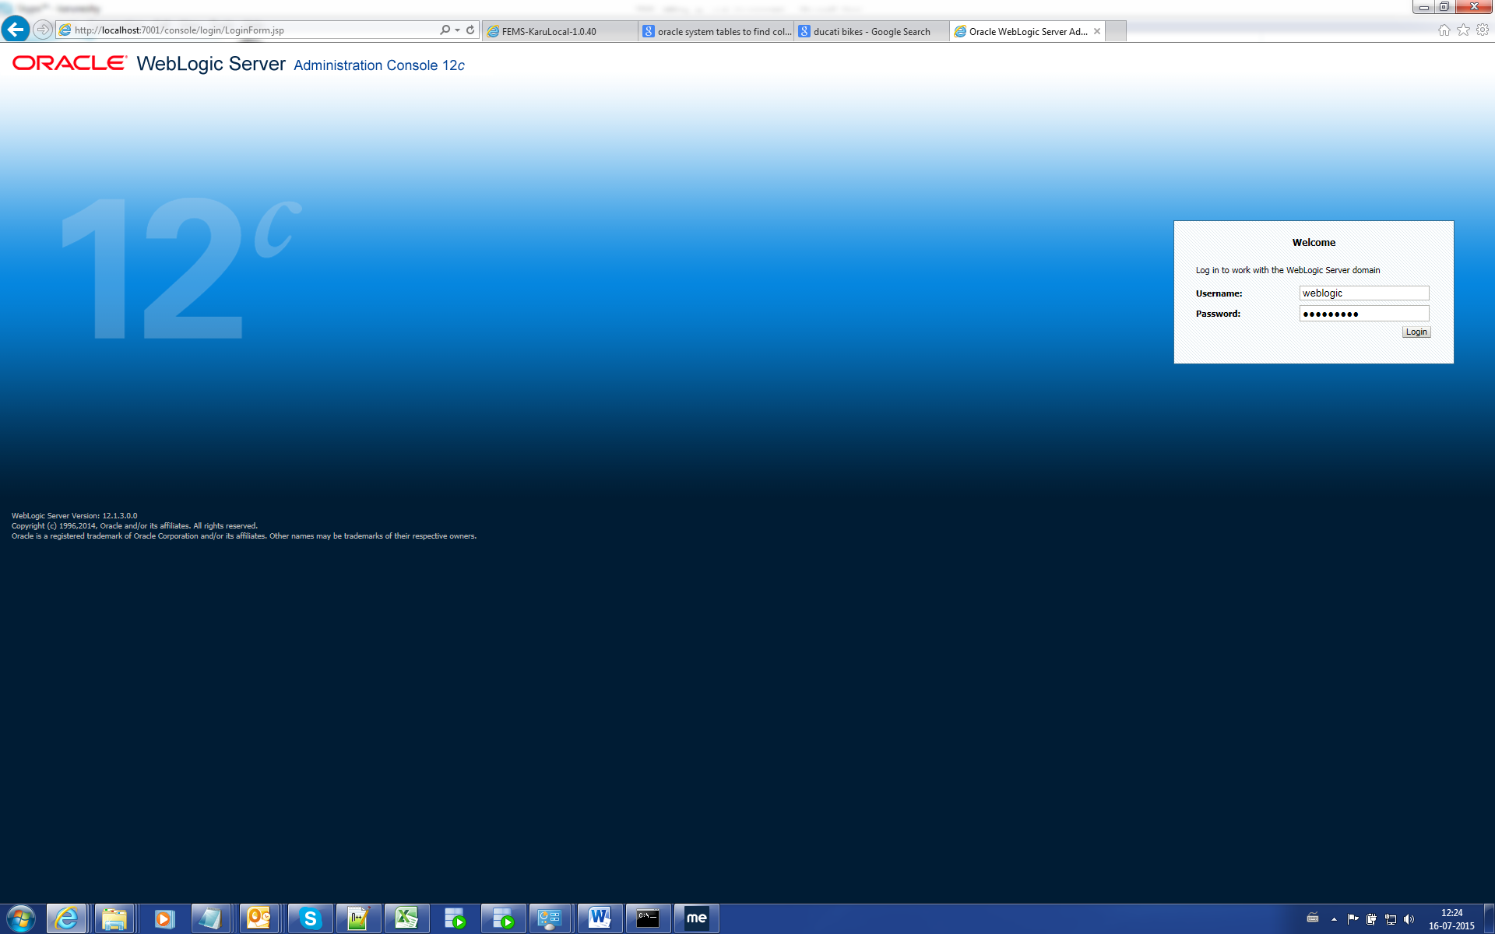

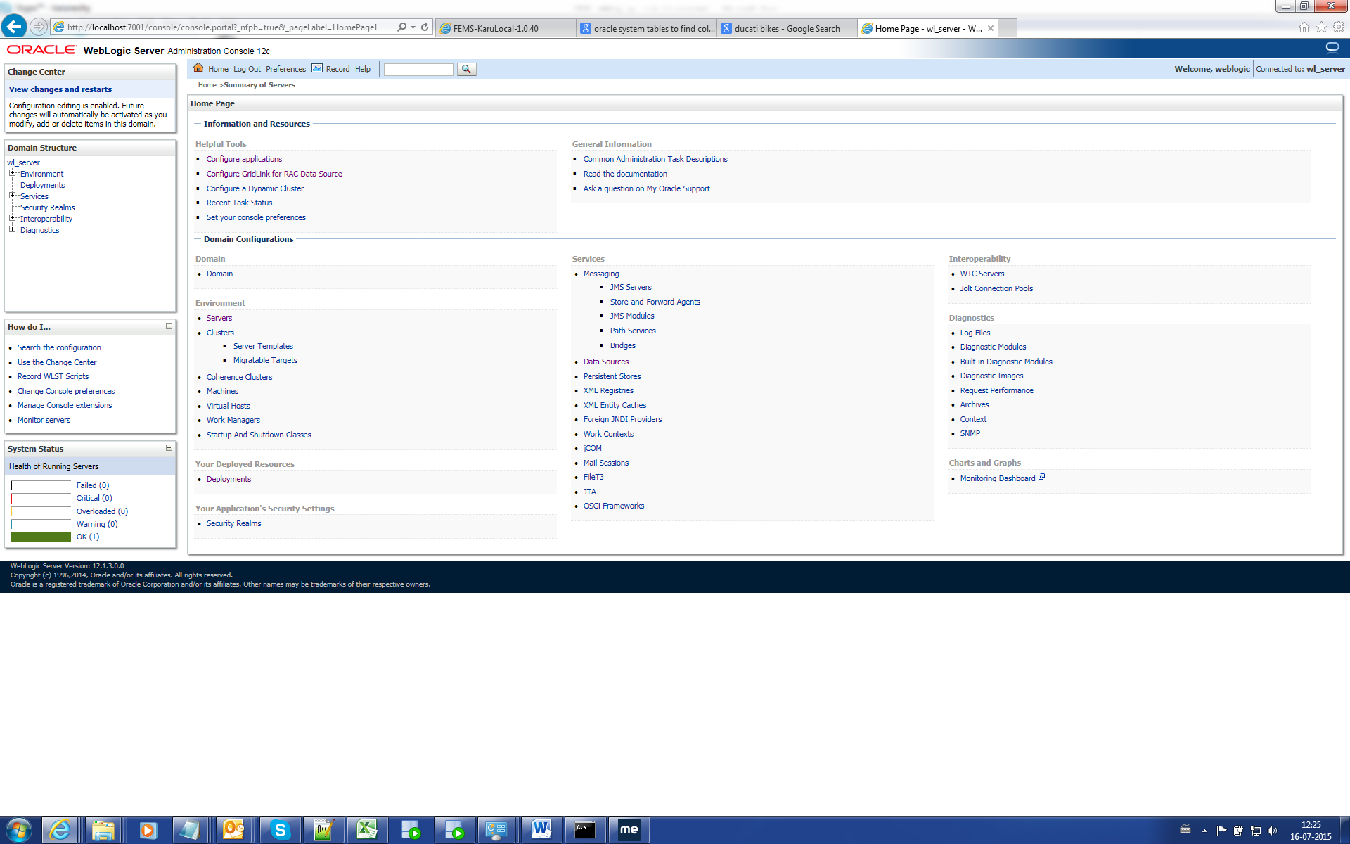

Click the Deployments and check the status. It should be RUNNING.

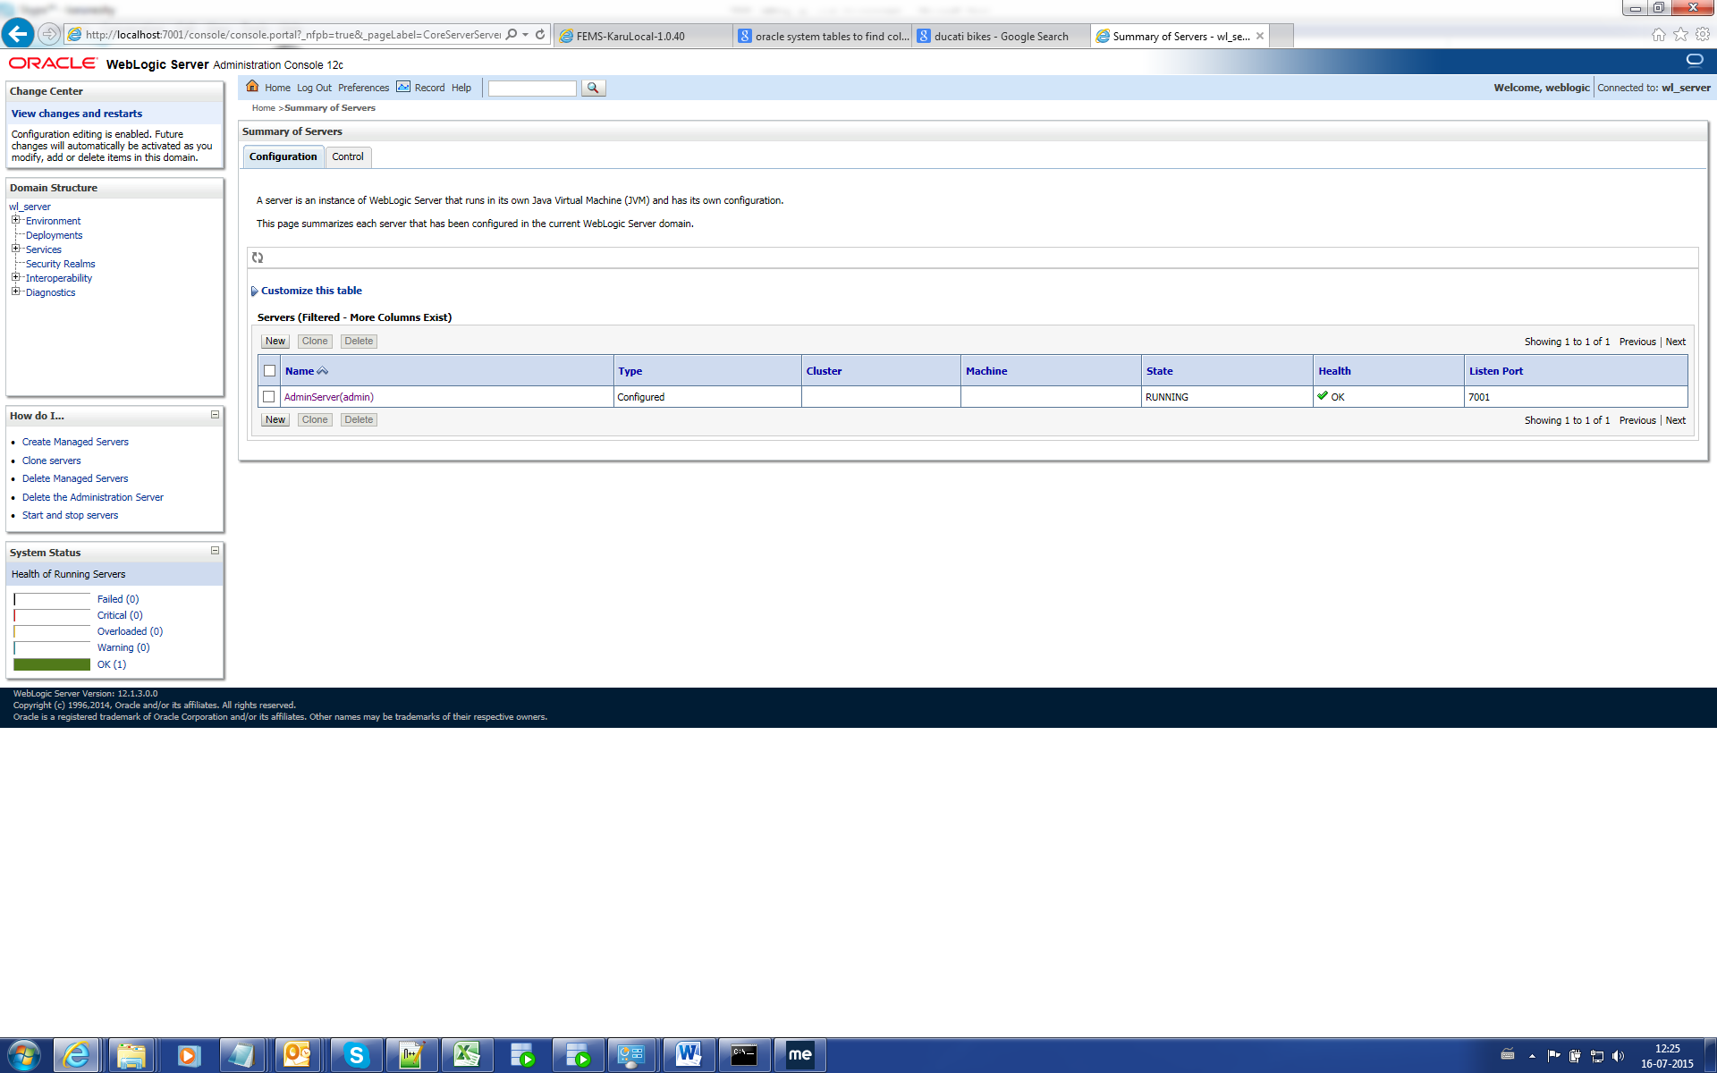

Launch application: <http://localhost:7001/examinWeb/DummyLogin.jsp>

**In case errors in Console:-**

* Add Properties folder in the project.
* Changes in weblogic.xml as below.

<?xml version=*"1.0"* encoding=*"UTF-8"*?>

<!DOCTYPE weblogic-web-app PUBLIC "-//BEA Systems, Inc.//DTD Web Application 6.1//EN" "http://www.bea.com/servers/wls700/dtd/weblogic700-web-jar.dtd">

<weblogic-web-app>

<servlet-descriptor>

<servlet-name>Init</servlet-name>

<init-as-principal-name>weblogic</init-as-principal-name>

</servlet-descriptor>

<servlet-descriptor>

<servlet-name>PreCache</servlet-name>

<init-as-principal-name>weblogic</init-as-principal-name>

</servlet-descriptor>

<servlet-descriptor>

<servlet-name>action</servlet-name>

<init-as-principal-name>weblogic</init-as-principal-name>

</servlet-descriptor>

<servlet-descriptor>

<servlet-name>initialisationServlet</servlet-name>

<init-as-principal-name>weblogic</init-as-principal-name>

</servlet-descriptor>

<security-role-assignment>

<role-name>examin_role</role-name>

<principal-name>weblogic</principal-name>

</security-role-assignment>

<session-descriptor>

<session-param>

<param-name>TimeoutSecs</param-name>

<param-value>7200</param-value>

</session-param>

</session-descriptor>

</weblogic-web-app>